PG-DASSD March 2022

Roll No: 220350329017

Name: Lokhande Sani Rajesh

C Assignment

Day 2 – Hyd

1. Write a C program to calculate volume of a box. A box can be represented by three quantities: length, width and height in inches. Volume can be calculated as:

volume = height * length * width

Take the input from user (using scanf) and print the volume as a result. Use float data types for all variables.

Program:

#include<stdio.h>

int main()

{

float hight, lenght, width, volume;

printf("please enter hight in inches\t");

scanf("%f",&hight);

printf("please enter length in inches \t");

scanf("%f",&lenght);

printf("please enter width in inches \t");

scanf("%f",&width);

volume=hight*lenght*width;

printf("Volume is thththththth %.2f \n \a",volume);

return 0;

}

Output:

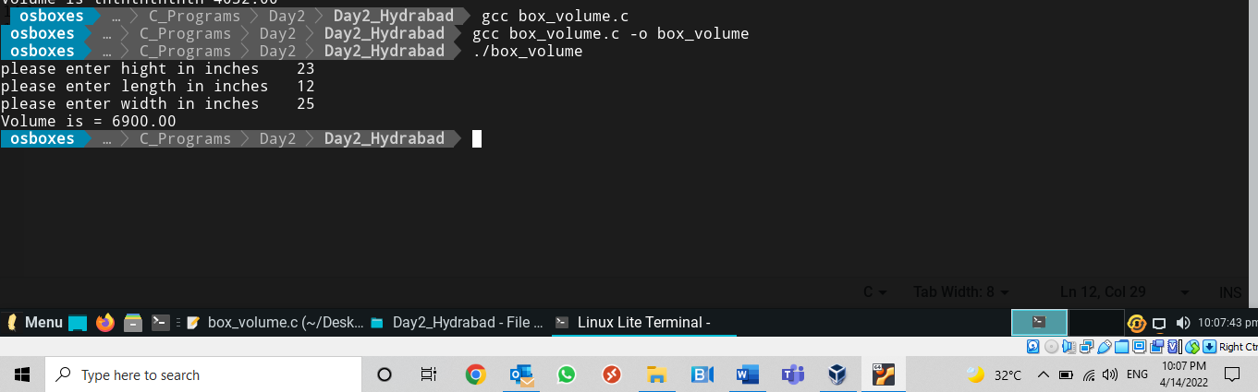

1. Write a program to calculate area and circumference of a circle using formula: 𝑎𝑟𝑒𝑎=𝜋𝑟2 and 𝑐𝑖𝑟𝑐𝑢𝑚𝑓𝑒𝑟𝑒𝑛𝑐𝑒=2𝜋r. Take the input r from the user.

Note: C doesn’t have an exponentiation operator, so that you will need to multiply x by itself repeatedly to compute powers of x. (For example, 𝑥∗𝑥 𝑖𝑠 𝑥2)

Program:

#include<stdio.h>

int main()

{

float radius, area, circu;

const float pi =3.14;

printf("\n Please enter radius of a circle");

scanf("%f",&radius);

area = pi*radius*radius;

circu = 2*pi*radius;

printf("\n Area of Circle = %.2f ",area);

printf("\n Circuferance of circle is = %.2f \n",circu);

return 0;

}

Output:

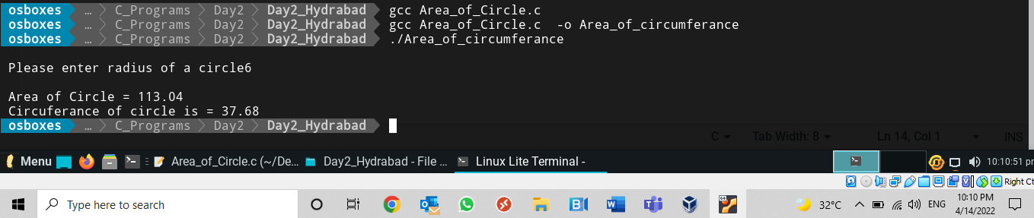

–

1. Write a program to calculate volume of a sphere with 10-meter radius, using the formula 𝑣=4/3𝜋𝑟3. Write the fraction 4/3 as 4.0f/3.0f (Also Try writing 4/3 and see what happens?). Use variable name for 𝜋 as PI and store value as 22.0f/7.0f. Modify same program and prompt the user to enter the radius.

Program:

#include<stdio.h>

int main()

{

int r =10;

const float pi=22.0f/7.0f;

float volume;

printf("\n %f",pi);

printf("\nPlease enter radius ");

scanf("%d",&r);

volume = (4.0f/3.0f)*pi*r*r;

printf("\n Volume of Sphere = %f \n",volume);

return 0;

}

Output:

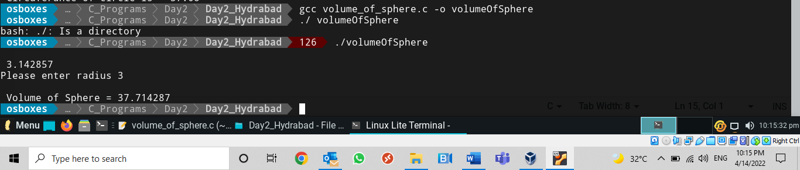

1. Write a program that asks the user to enter a value for x and then displays the value of the following polynomial: 6𝑥5+ 5𝑥4−4𝑥3+3𝑥2+2𝑥+1

Program:

#include<stdio.h>

#include<math.h>

int main()

{

int x;

long int poly;

printf("\n Please enter the value of X=");

scanf("%d",&x);

poly=6*pow(x,5)+5*pow(x,4)-4*pow(x,3)+3*pow(x,2)+2*x+1;

printf("\nPolinomial = %ld\n",poly);

return 0;

}

Output:

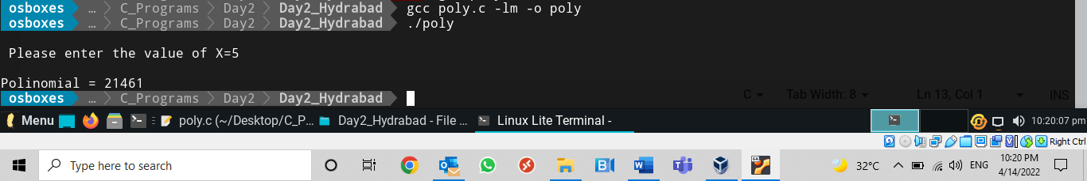

1. Write a program to calculate simple interest using formula: 𝑠𝑖=𝑝𝑟𝑖𝑛𝑐𝑖𝑝𝑙𝑒∗𝑟𝑎𝑡𝑒∗𝑡𝑖𝑚𝑒. Take all variable as float type.

Program:

include<stdio.h>

int main()

{

float si,p,r,t;

printf("\nPlease enter principle Amount =");

scanf("%f",&p);

printf("\nPlease enter rate of interest =");

scanf("%f",&r);

printf("\nPlease enter period =");

scanf("%f",&t);

si=p*(r/100)*t;

printf("\nSimple Interest = %f \n",si);

return 0;

}

Output:

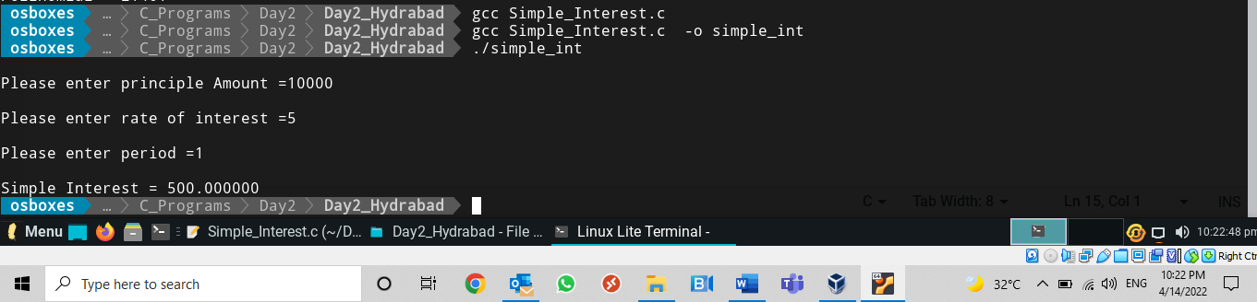

DAY 2- Bang

1. Develop a C program to perform operations (+,*,-, / and %) on two whole numbers. Identify suitable data types to represent the numbers and resultant values;

Program:

#include<stdio.h>

int main()

{

int a,b, result;

a=55;

b=6;

result=a+b;

printf("\nAddition is %d",result);

result=a-b;

printf("\nSubstraction is %d",result);

result=a*b;

printf("\nMultiplication is %d",result);

result=(float)a/b;

printf("\nDivision is %d",result);

result=a%b;

printf("\nReminder is %d \n",result);

return 0;

}

Output:

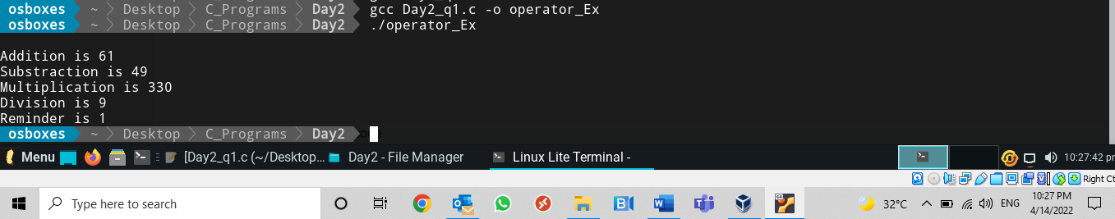

1. Write a program to demonstrate bitwise operators

Program:

#include<stdio.h>

int main()

{

int a=15,b=10;

printf("\n Bitwise AND opearator %d",a&b);

printf("\n Bitwise OR opearator %d",a|b);

printf("\n Bitwise XOR opearator %d",a^b);

printf("\n Bitwise Exclusive 1 complement opearator %d",~b);

printf("\n Bitwise Left Shift opearator %d",b<<2);

printf("\n Bitwise Right Shift opearator %d \n ",b>>2);

return 0;

}

Output:

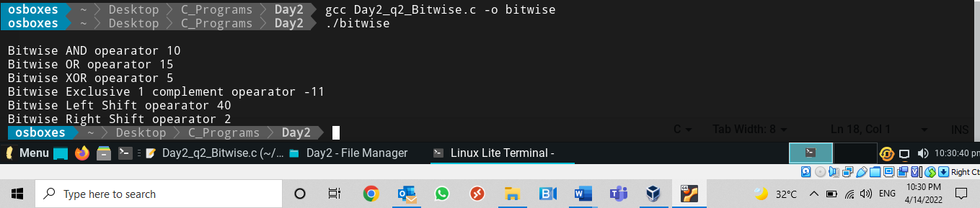

1. Develop a C program to add two operands and store the result in one of the operand using addition assignment operator.( a+=b is same as a=a+b)

Program:

#include<stdio.h>

int main()

{

int a=19,b=34;

a+=b;

printf("Additions is = %d\n",a);

return 0;

}

Output:

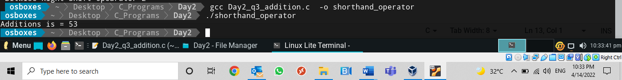

1. Write a C program to find the maximum of 2 numbers using Conditional operator.

Program:

#include<stdio.h>

int main()

{

int num1,num2;

printf("Please enter two numbers");

scanf("%d%d",&num1,&num2);

num1>num2?printf("\n Number %d is maximum number\n ",num1):printf("\n Number %d is maximum number\n ",num2);

return 0;

}

Output:

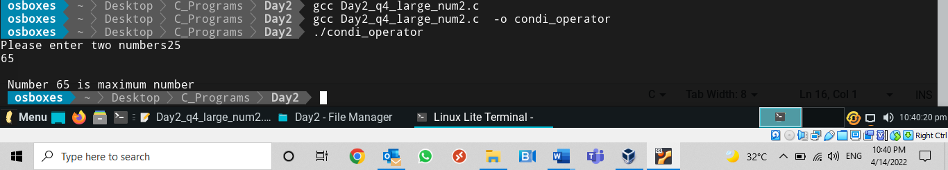

1. A C program contains the following declarations and initial assignments:

int i= 8, j = 5;

float x = 0.005, y = 0.01;

char c = ‘c’, d = ‘d’;

Determine the value of each of the following expressions.

* (3*i*j)%(2*d) = 120%200 =120
* (i*j)%(c+2*d) / (x*y) =(40)%(297)/0.00005 =40%5,940,000 =
* 5 * (i + j) > 'c' =5*13>97 =65>97=0 “False”
* 2*x+ (y== 0) =0.01+0 (“False”) =0.01
* (x > y) && (i > 0) || (j < 5) =0 && 1 || 0 = 0

Program:

#include<stdio.h>

int main()

{

int i=8,j=5;

float x=0.005f,y=0.01f ;

char c='c', d='d';

double result;

result = (3*i*j)%(2*d);

printf("\n 1.(3*i*j)%(2*d) = %f ",result);

result = (i*j)%(c+2*d)/(x*y);

printf("\n 2. (i*j)%(c+2*d) / (x*y) = %f ",result);

result = 5*(i+j)>c;

printf("\n 3. 5 * (i + j) > 'c' = %f ",result);

result = 2*x + (y==0);

printf("\n 4. 2*x+ (y== 0) = %f ",result);

result = ((x>y) && (i>0) || (j<5));

printf("\n 5. (x > y) && (i > 0) || (j < 5) = %f \n",result);

return 0;

}

Output:

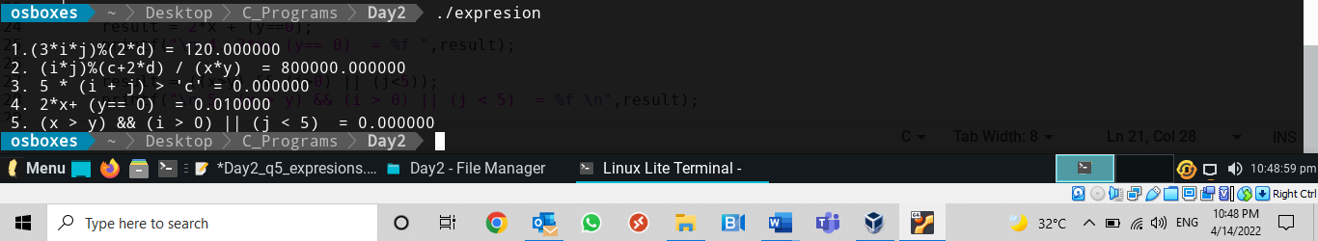

1. Write a program to find the area and the perimeter of a circle.

Take radius “r” as input

Program:

#include<stdio.h>

int main()

{

float radius, area, circu;

const float pi =3.14;

printf("\n Please enter radius of a circle");

scanf("%f",&radius);

area = pi*radius*radius;

circu = 2*pi*radius;

printf("\n Area of Circle = %.2f ",area);

printf("\n periemeter of circle is = %.2f \n",circu);

return 0;

}

Output:

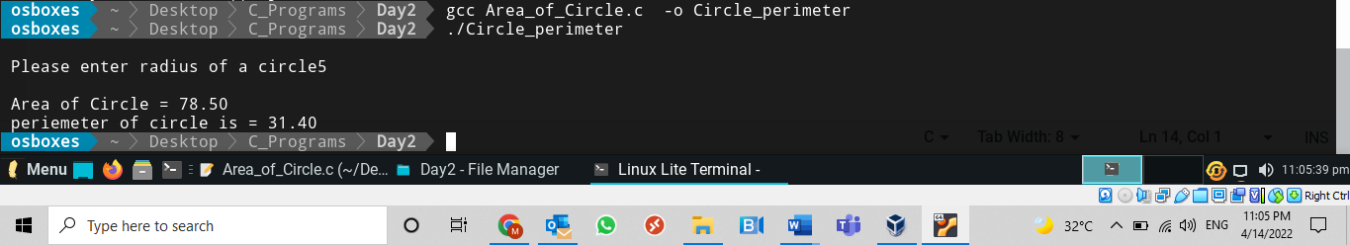

1. Develop a C program to calculate simple interest using the formula I=PTR/100.

Program:

include<stdio.h>

int main()

{

float si,p,r,t;

printf("\nPlease enter principle Amount =");

scanf("%f",&p);

printf("\nPlease enter rate of interest =");

scanf("%f",&r);

printf("\nPlease enter period =");

scanf("%f",&t);

si=p*(r/100)*t;

printf("\nSimple Interest = %f \n",si);

return 0;

}

Output:



Day 3- Bang

1. Develop a C program which adds all numbers from 1 to N, except those which are divisible by 5. Implement this using for loop and continue statement.

Program:

#include<stdio.h>

int main()

{

int n,i;

int add;

printf("\nEnter the max no you want to add");

scanf("%d",&n);

add=0;

for(i=1;i<=n;i++)

{

if(i%5==0)

continue;

add=add+i;

}

printf("\n addtion till the %d = %d \n",n,add);

return 0;

}

Output:

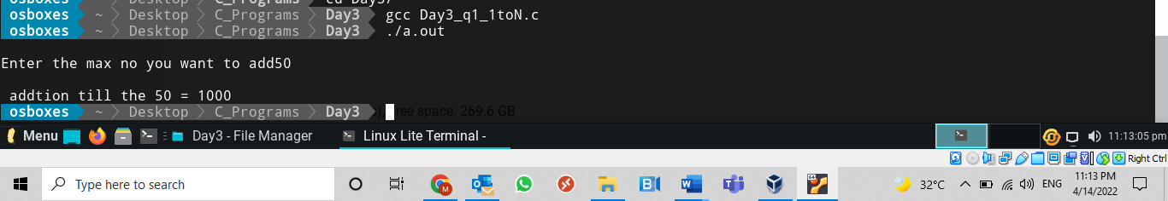

1. Develop a C program to find sum of all odd numbers upto N using while loop.

Program:

#include<stdio.h>

int main()

{

int n,i;

int add;

printf("\nEnter the max no you want to add");

scanf("%d",&n);

add=0;

for(i=1;i<=n;i++)

{

if(i%2!=0)

add=add+i;

}

printf("\n addtion of odd numbers till the %d = %d \n",n,add);

return 0;

}

Output:

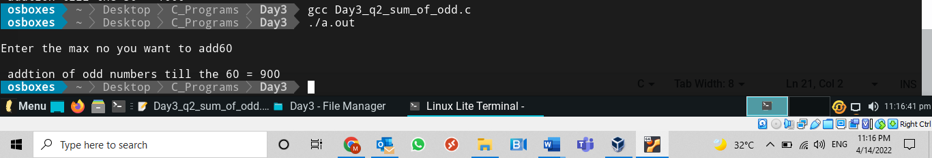

1. Write a program to find whether given number is palindrome or not.

Program:

#include<stdio.h>

int main()

{

int num,i,sum=0,r,temp;

printf("Enter the number");

scanf("%d",&num);

temp=num;

while(num>0)

{

r=num%10;

sum=sum*10+r;

num=num/10;

}

if(sum==temp)

printf("\n %d number is Palindrome\n",temp);

else

printf("\n %d number is not palindrome \n",temp);

return 0;

}

Output:

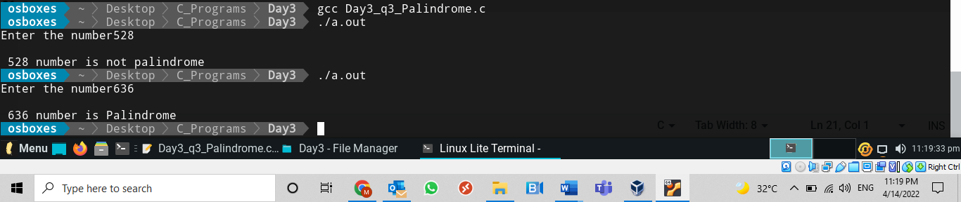

1. Write a program in C to display the pattern like right angle triangle as shown pattern below.

1

12

123

1234

Program:

#include<stdio.h>

int main()

{

int i,j,n;

printf("enter the max line you want to print ");

scanf("%d",&n);

for(i=1;i<=n;i++)

{

for(j=1;j<=i;j++)

{

printf("%d",j);

}

printf("\n");

}

return 0;

}

Output:

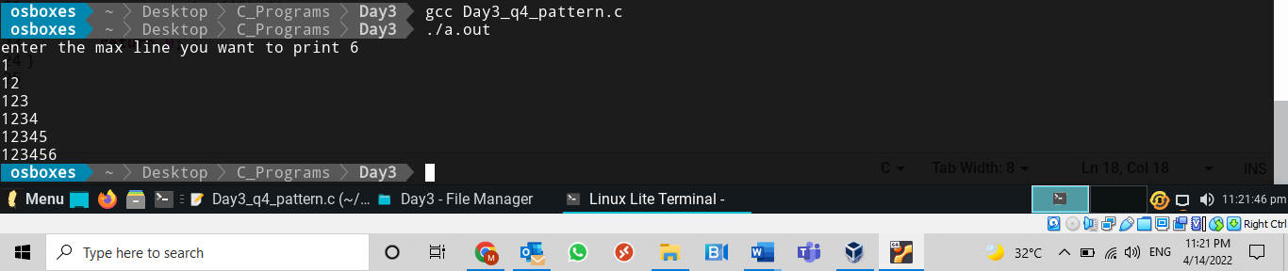

1. Write a program in C to display the pattern like right angle triangle as shown pattern below.

1

22

333

4444

Program:

#include<stdio.h>

int main()

{

int i,j,n;

printf("enter the max line you want to print ");

scanf("%d",&n);

for(i=1;i<=n;i++)

{

for(j=1;j<=i;j++)

{

printf("%d",j);

}

printf("\n");

}

return 0;

}

Output:

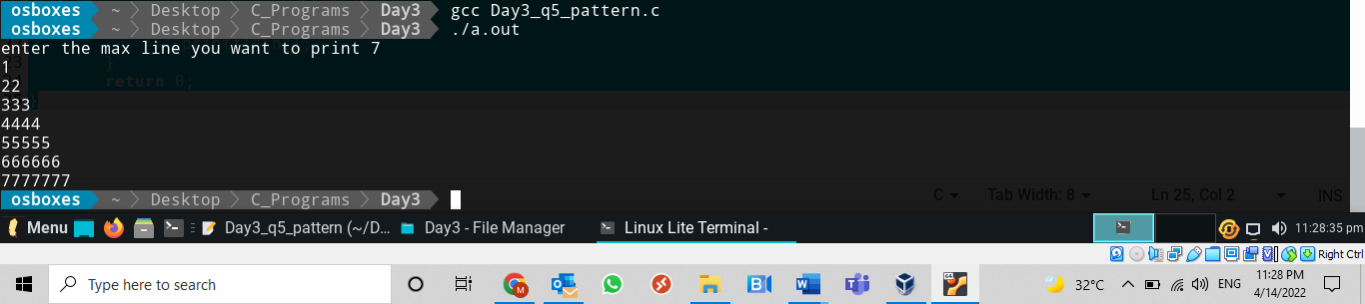

1. Write a C program to display the pattern like right angle triangle as shown pattern below.

1

2 3

4 5 6

7 8 9 10

Program:

#include<stdio.h>

int main()

{

int i,j,n,t;

printf("enter the max line you want to print ");

scanf("%d",&n);

t=1;

for(i=1;i<=n;i++)

{

for(j=1;j<=i;j++)

{

printf("%d ",t);

t++;

}

printf("\n");

}

return 0;

}

Output:

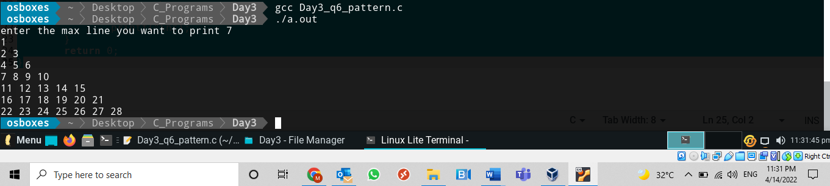

Day4- Bang

1. Write a swap function to perform the swap operation

Program:

#include<stdio.h>

int swap(int a,int b);

int main()

{

int a,b;

printf("\nPlease enter to swap the numbers");

scanf("%d%d",&a,&b);

printf("\n value of a = %d",a);

printf("\n Value of b = %d",b);

swap(a,b);

return 0;

}

int swap(int a,int b)

{

int c;

c=a;

a=b;

b=c;

printf("\n Values after swap:");

printf("\n Value of a = %d",a);

printf("\n Value of b = %d\n",b);

return 0;

}

Output:

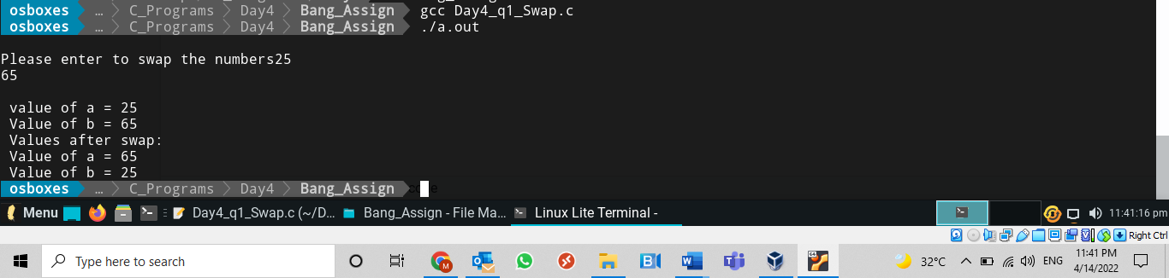

1. Write a program to find the GCD of two numbers.

Take two integers as input, find the GCD and return it to main.

Program

#include<stdio.h>

int main()

{

int i,num1,num2,GCD,low_num;

printf("enter two numbers");

scanf("%d%d",&num1,&num2);

if(num1>num2)

low_num=num2;

else

low_num=num1;

GCD=1;

for(i=1;i<=low_num;i++)

{

if(num1%i==0 && num2%i==0)

GCD=i;

}

printf("HCF \\ GCD for %d and %d = %d",num1,num2,GCD);

}

Output:

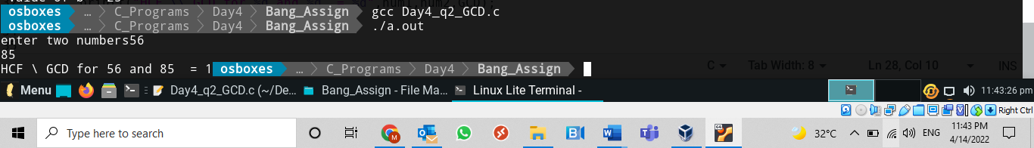

1. Write a program to print the prime Fibonacci numbers in a given range.

Program:

#include<stdio.h>

int main()

{

int pre =1, present=1,fibbo=0; // prime starts from 2 so pre assigned to 1

int range,count,i;

printf("Enter the range for Fiboonace");

scanf("%d",&range);

//printf("%d\t",fibbo); prime numbers starts from 2 so commented

//printf("1\t");

while(fibbo<=range)

{

fibbo=pre+present;

pre=present;

present=fibbo;

count=0;

for(i=2;i<fibbo;i++)

{

if(fibbo%i==0)

count++;

}

if(count==0 && fibbo<=range)

printf("%d\t",fibbo);

}

printf("\n");

return 0;

}

Output:

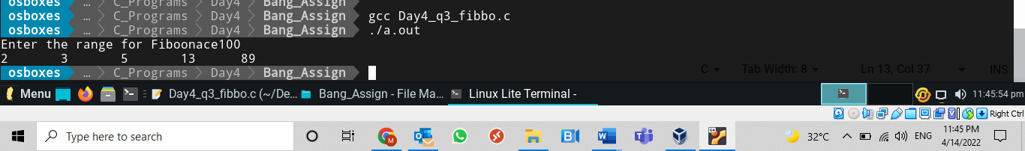

1. Take the range of numbers as input and print all the prime Fibonacci numbers as output. Use Functions. Try with non-recursive and recursive functions

Program;

//Non recursive

#include<stdio.h>

int fibbonace(int range);

int main()

{

int range;

printf("Enter the range for Fiboonace");

scanf("%d",&range);

fibbonace(range);

printf("\n");

return 0;

}

int fibbonace(int range)

{

int pre =1, present=1,fibbo=0;

int count,i;

//printf("%d\t",fibbo); prime number start from 2

//printf("1\t");

while(fibbo<=range)

{

fibbo=pre+present;

pre=present;

present=fibbo;

count=0;

for(i=2;i<fibbo;i++)

{

if(fibbo%i==0)

count++;

}

if(count==0 && fibbo<=range)

printf("%d\t",fibbo);

}

}

Output:

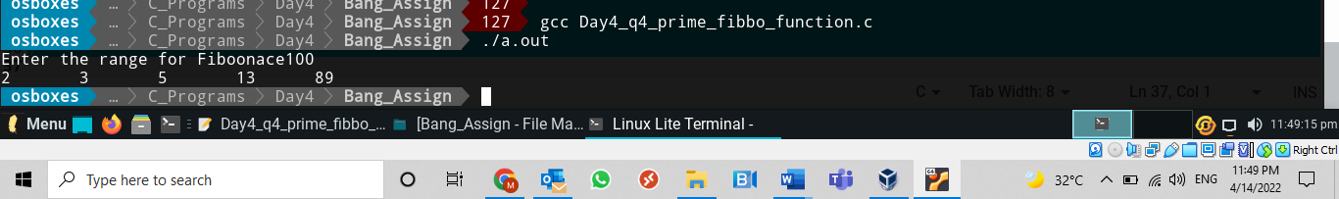

//With recursive

Program:

#include<stdio.h>

void fibbonace(int range);

int pre =1, present=1,fibbo=0;

int count,i;

void main()

{

int range;

printf("Enter the range for Fiboonace");

scanf("%d",&range);

fibbonace(range);

printf("\n");

//return 0;

}

void fibbonace(int range)

{

//printf("%d\t",fibbo); prime number start from 2

//printf("1\t");

fibbo=pre+present;

pre=present;

present=fibbo;

count=0;

for(i=2;i<fibbo;i++)

{

if(fibbo%i==0)

count++;

}

if(count==0 && fibbo<=range)

printf("%d\t",fibbo);

if(fibbo<=range)

fibbonace(range);

}

Output:

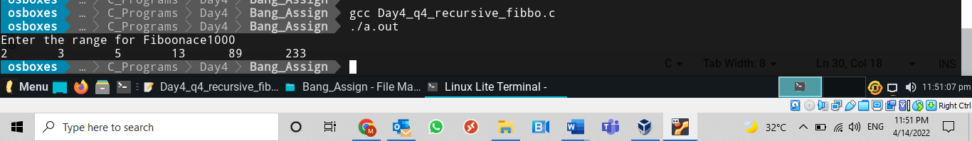

1. Write a program to reverse an integer number.

Use recursion.

Program:

#include<stdio.h>

int reverse(int num);

int rev=0;

int main()

{

int num;

printf("Enter the Number");

scanf("%d",&num);

reverse(num);

printf("%d Reverse number is %d\n ",num,rev);

return 0;

}

int reverse(int num)

{

int r;

if(num>0)

{

r=num%10;

rev=rev*10+r;

num=num/10;

reverse(num);

}

return 0;

}

Output:

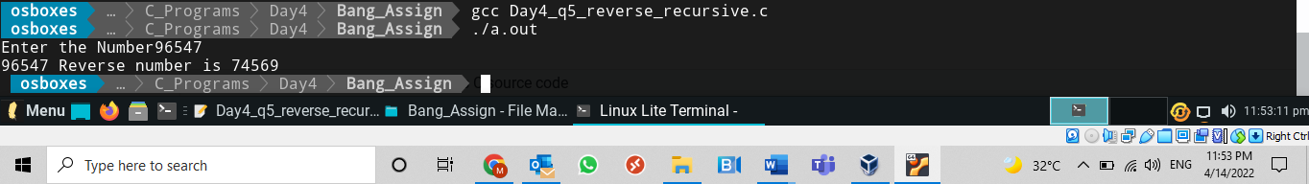

1. Write a recursive function to find factorial of a number.

Program:

#include<stdio.h>

int facto(int num);

long int sum=1;

int main()

{

int num;

printf("Enter the Number");

scanf("%d",&num);

sum = facto(num);

printf("Factorial of %d is %li\n ",num,sum);

return 0;

}

int facto(int num)

{

if(num>1)

return num*facto(num-1);

}

Output:

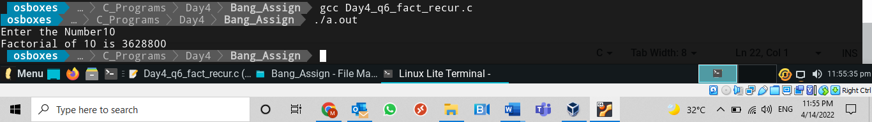

1. Write a function to swap contents of two variables using functions

Program:

#include<stdio.h>

int swap(int *a,int *b);

int main()

{

int a,b;

printf("\nPlease enter to swap the numbers");

scanf("%d%d",&a,&b);

printf("\n value of a = %d",a);

printf("\n Value of b = %d",b);

swap(&a,&b);

return 0;

}

int swap(int *a,int *b)

{

int c;

c=*a;

*a=*b;

*b=c;

printf("\n Values after swap:");

printf("\n Value of a = %d",*a);

printf("\n Value of b = %d\n",*b);

return 0;

}

Output:

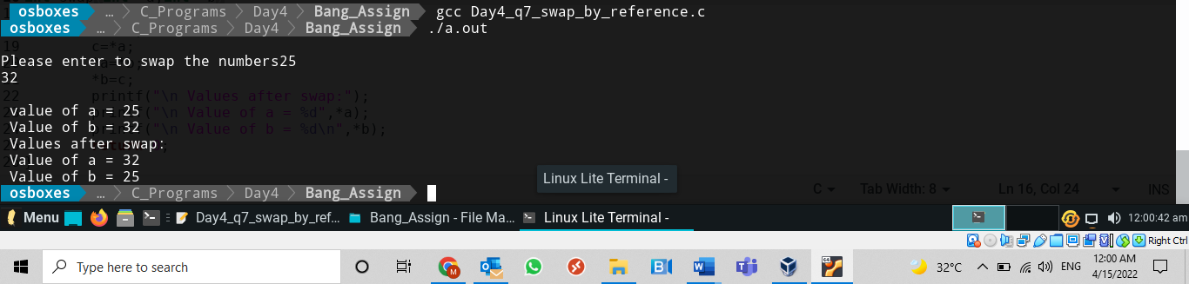

Day4 – HYD

1. Write a C program to check if a given Number is zero or Positive or Negative Using if...else statement

Program:

#include<stdio.h>

int main()

{

float num;

printf("Please enter the number =");

scanf("%f",&num);

if(num == 0)

printf("number is 0");

else if(num>0)

printf("Number is positive");

else

printf("Numner is negative");

return 0;

}

Output:

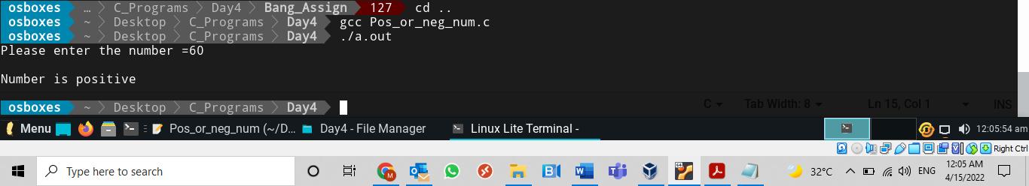

1. Write a C Program to find the Largest Integer among Three integers using if statement. Note: To take input using single line Use scanf(“%d %d %d”, &num1, &num2, &num3);

Program:

#include<stdio.h>

int main()

{

int num1,num2,num3;

printf("Please enter three numbers");

scanf("%d%d%d",&num1,&num2,&num3);

if(num1 ==num2 && num2==num3)

printf("All numbers are Equal");

else if(num1>num2 && num1>num3)

printf("number %d is Largest number",num1);

else if(num2>num1 && num2>num3)

printf("number %d is Largest number",num2);

else

printf("number %d is Largest number",num3);

return 0;

}

OutputL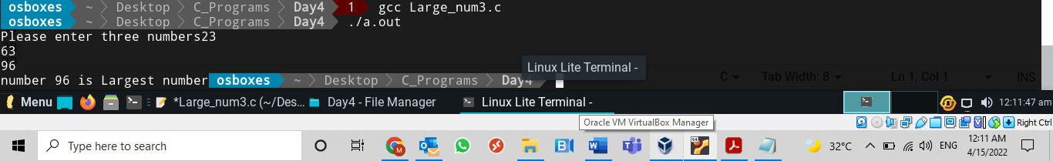

1. Write a C Program to find the Smallest Integer among Three integers using IF and Logical && operator

Program:

#include<stdio.h>

int main()

{

int num1,num2,num3;

printf("Please enter three numbers");

scanf("%d%d%d",&num1,&num2,&num3);

if(num1 ==num2 && num2==num3)

printf("All numbers are Equal");

else if(num1<num2 && num1<num3)

printf("number %d is Smallest number",num1);

else if(num2<num1 && num2<num3)

printf("number %d is Smallest number",num2);

else

printf("number %d is Smallest number",num3);

return 0;

}

Output:

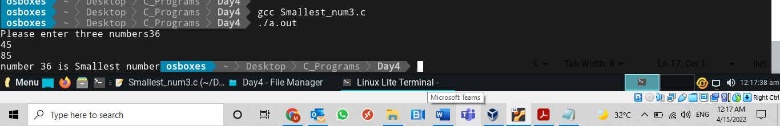

1. What is output of following program?

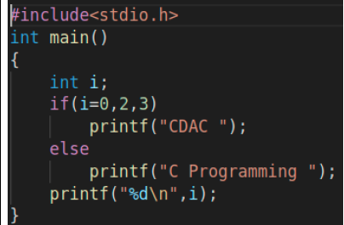

Program:

#include<stdio.h>

int main()

{

int i;

if(i =0,2,3)

printf("Cdac");

else

printf("Sunny");

printf("Lokhande%d",i);

return 0;

}

//output: CdacLokhande0

Output:

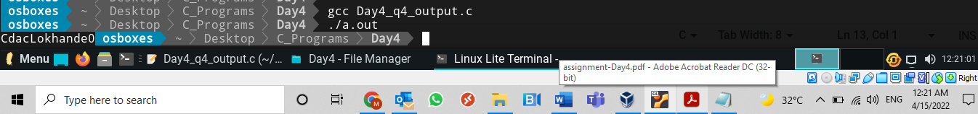

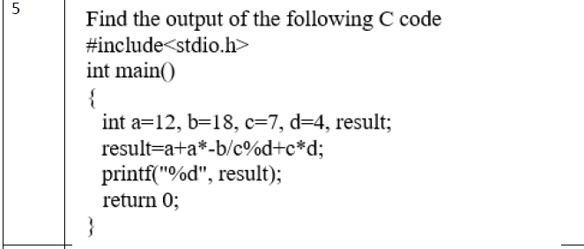

Program:

#include<stdio.h>

int main()

{

int a=12,b=18,c=7,d=4,result;

result=a+a*-b/c%d+c*d;

printf("%d",result);

return 0;

}

//Output

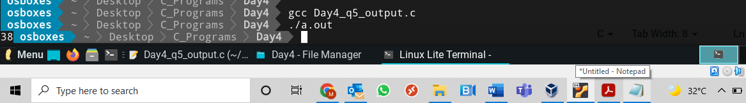



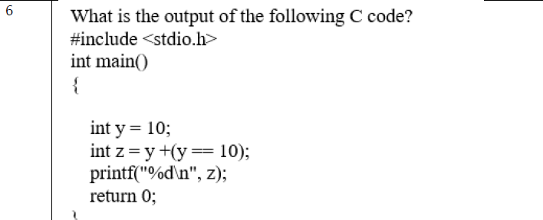

Program:

#include<stdio.h>

int main()

{

int y=10;

int z=y+(y==10);

printf("%d\n",z);

return 0;

}

Output:

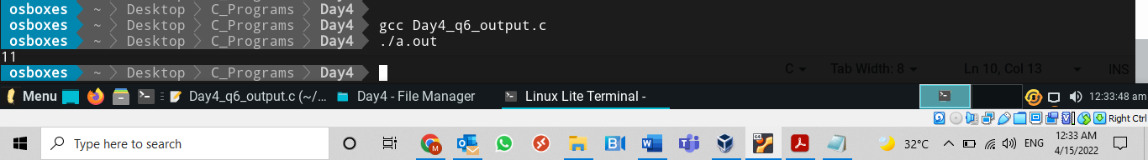



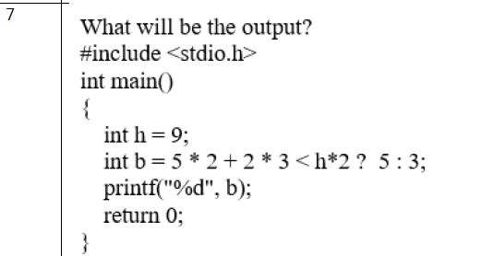

Program:

#include<stdio.h>

int main()

{

int h=9;

int b= 5*2+2*3<h*2?5:3;

printf("%d\n",b);

return 0;

}

Outpput1

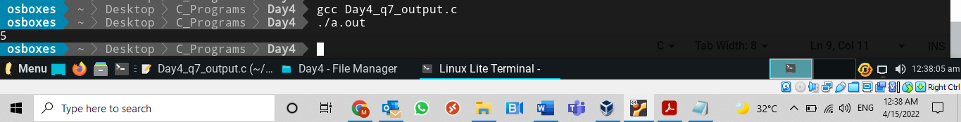



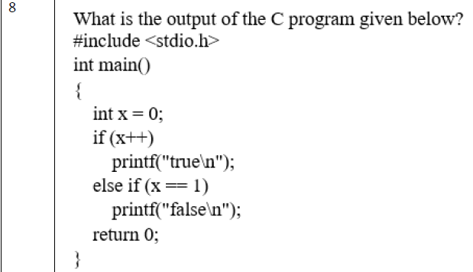

Program:

#include<stdio.h>

int main()

{

int x=0;

if(x++)

printf("true\n");

else if(x==1)

printf("False\n");

return 0;

}

Output:

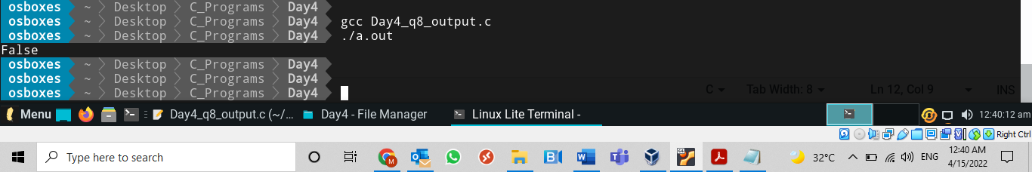



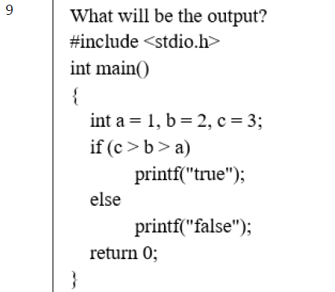

Program:

#include<stdio.h>

int main()

{

int a=1,b=2,c=3;

if(c>b>a)

printf("True\n");

else

printf("False\n");

return 0;

}

Output:

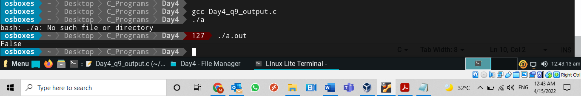

7



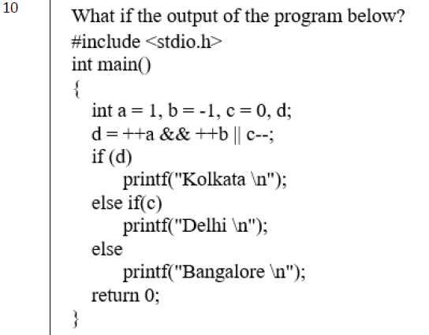

Program:

#include<stdio.h>

int main()

{

int a=1,b=-1,c=0,d;

d=++a&&++b||c; //2&&0||0 = 0||0 = 0

if(d) //0 = False

printf("kolkata \n");

else if(c) //c=0 = false

printf("Delhi \n");

else

printf("Bangalore \n"); //will print this

return 0;

}

Output:

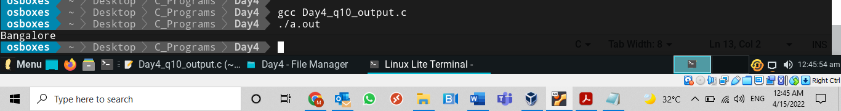

Day 5

1. [Write a C program to find the sum of all array elements](http://codeforwin.blogspot.com/2015/07/c-program-to-find-sum-of-all-elements-of-array.html).

Program:

#include<stdio.h>

int main()

{

int a[50],i,sum,n;

printf("enter the array limit");

scanf("%d",&n);

for(i=0;i<n;i++)

{

printf("enter %d th number",i+1);

scanf("%d",&a[i]);

}

for(i=0;i<n;i++)

{

sum=sum+a[i];

}

printf("Sum of all array elements = %d\n",sum);

return 0;

}

Output:

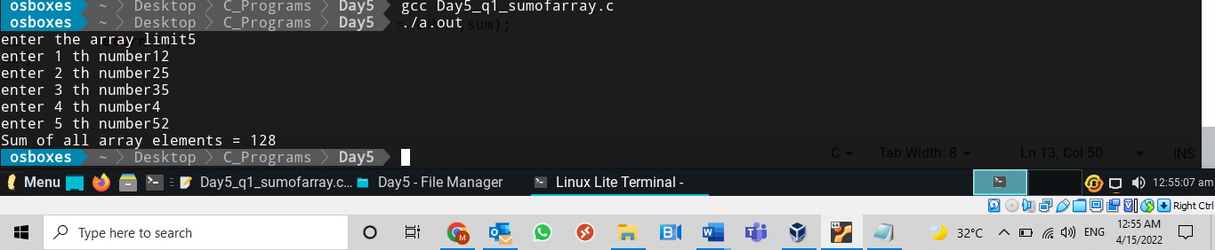

1. Write a C program to count the frequency of each number in a 1-D array. All the elements in the array are integers.

Program:

#include<stdio.h>

int main()

{

int a[50],i,j,count,n;

printf("\nenter the array limit");

scanf("%d",&n);

for(i=0;i<n;i++)

{

printf("\nenter %d th number",i+1);

scanf("%d",&a[i]);

}

for(i=0;i<n;i++)

{

count =0;

for(j=0;j<n;j++)

{

if(a[i]==a[j])

count++;

}

printf("\nfrquency of number %d is = %d\n",a[i],count);

}

return 0;

}

Output:

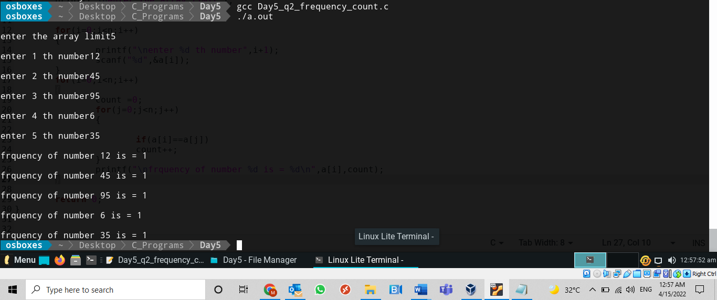

1. Write a C Program to display one dimensional array elements with addresses

Program:

#include<stdio.h>

int main()

{

int a[50],i;

int n;

printf("\nenter the array limit");

scanf("%d",&n);

for(i=0;i<n;i++)

{

printf("\nenter %d th number",i+1);

scanf("%d",&a[i]);

}

for(i=0;i<n;i++)

printf("\n %d element is %d and address is %p",i+1,a[i],&a[i]);

return 0;

}

Output:

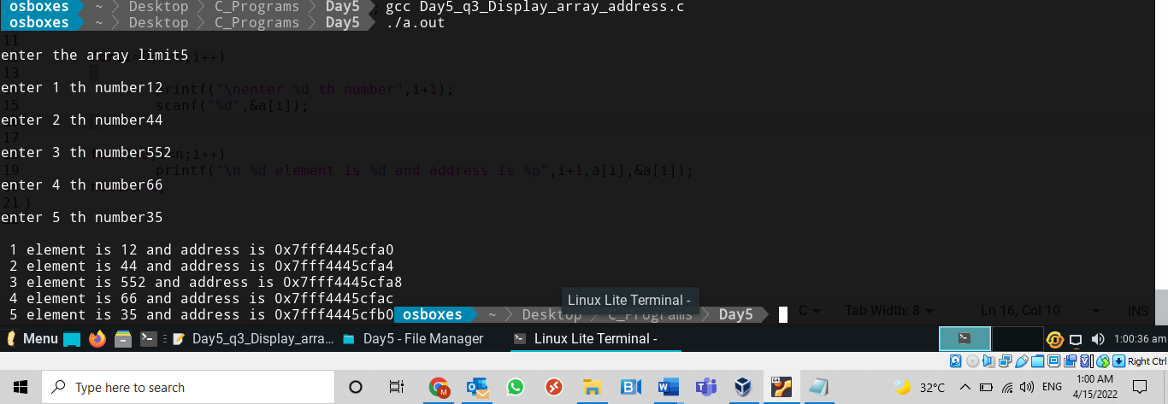

1. Write a C Program to Find Greatest Element in Array in one dimensional array

Program:

#include<stdio.h>

int main()

{

int a[50],i,large,n;

printf("\nenter the array limit");

scanf("%d",&n);

for(i=0;i<n;i++)

{

printf("\nenter %d th number",i+1);

scanf("%d",&a[i]);

}

large=0;

for(i=0;i<n;i++)

{

if(large<a[i])

large=a[i];

}

printf("\n Largest number in array is %d",large);

return 0;

}

Output:

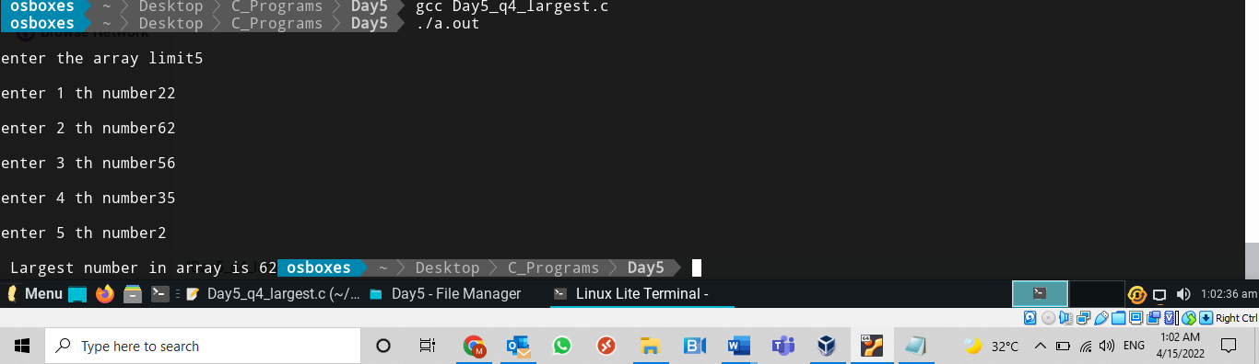

1. Write a C Program to Reversing the 1-D Array Elements

Program:

#include<stdio.h>

int main()

{

int a[50],b[50],i,n,bn;

printf("\nenter the array limit");

scanf("%d",&n);

for(i=0;i<n;i++)

{

printf("\nenter %d number",i+1);

scanf("%d",&a[i]);

}

bn=n-1;

for(i=0;i<n;i++)

{

if(bn>=0)

b[bn]=a[i];

bn--;

}

printf("Array elements after reversing as below:");

for(i=0;i<n;i++)

{

printf("\n%d Element of an Array is %d\n",i+1,b[i]);

}

return 0;

}

Output:

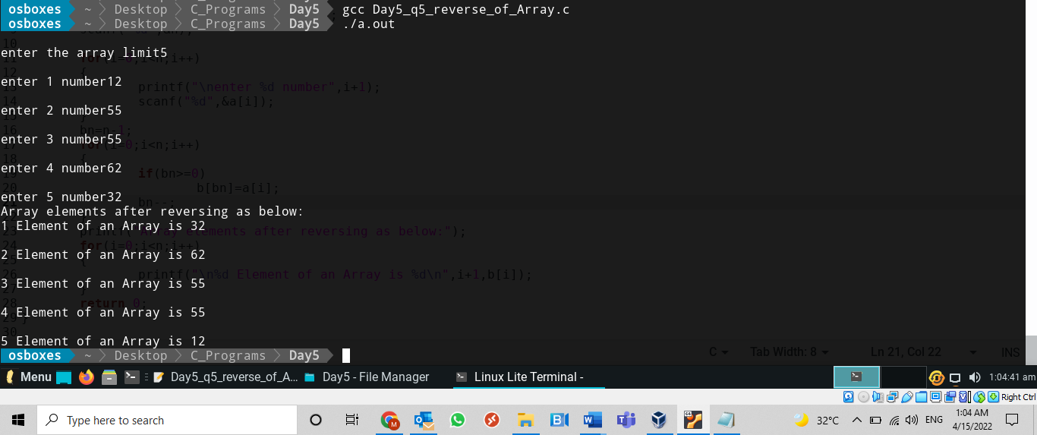

1. Write a C Program to sort elements in 1-D Array

Program:

#include<stdio.h>

int main()

{

int a[50],b[50],i,j,k,n;

int smallest;

printf("\nenter the array limit");

scanf("%d",&n);

for(i=0;i<n;i++)

{

printf("\nenter %d th number",i+1);

scanf("%d",&a[i]);

}

for(j=0;j<n;j++)

{

smallest=a[j];

for(k=j;k<n;k++)

{

if(a[j]<a[k])

{

smallest=a[j];

a[j]=a[k];

a[k]=smallest;

}

}

}

printf("\nsorted array given as below :");

for(i=0;i<n;i++)

{

printf("\n %d element is %d",i+1,a[i]);

}

return 0;

}

Output:

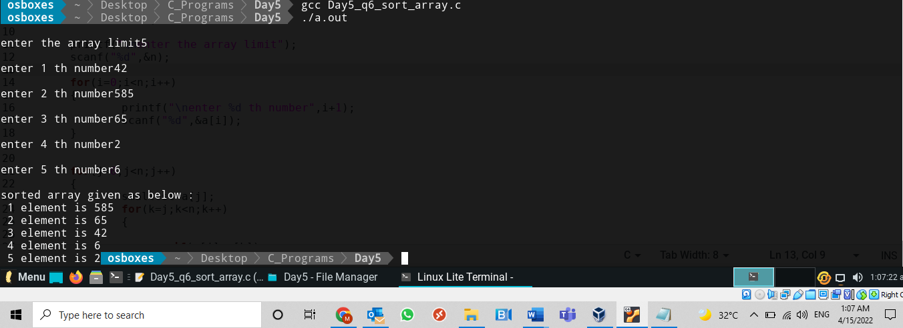

1. Write a program to remove the duplicate elements in an integer array.

Program:

#include<stdio.h>

int main()

{

int a[50],n,i,j,b[50],bn=0,count=0;

printf("Enter the limit for an array");

scanf("%d",&n);

for(i=0;i<n;i++)

{

printf("Enter the %d element",i+1);

scanf("%d",&a[i]);

}

for(i=0;i<n;i++)

{ count=0;

for(j=0;j<bn;j++)

{

if(a[i]==b[j])

count++;

}

if(count==0)

{

b[bn]=a[i];

bn++;

}

}

printf("\nAfter removing Duplicates deom array = ");

for(i=0;i<bn;i++)

{

printf("\t %d",b[i]);

}

return 0;

}

Output:

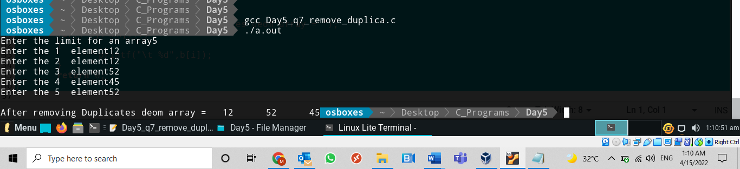

1. Write a C Program to display two-dimensional array elements with addresses

Program:

#include<stdio.h>

int main()

{

int a[50][50],i,j;

int row,col;

printf("\nenter the 2-D array dimentions");

scanf("%d%d",&row,&col);

for(i=0;i<row;i++)

{

for(j=0;j<col;j++)

{

printf("\nEnter %d X %d number",i,j);

scanf("%d",&a[i][j]);

}

}

for(i=0;i<row;i++)

{

for(j=0;j<col;j++)

{

printf("\n %d X %d Element is %d and address is %p",i,j,a[i][j],&a[i][j]);

}

}

printf("\n");

return 0;

}

Output:

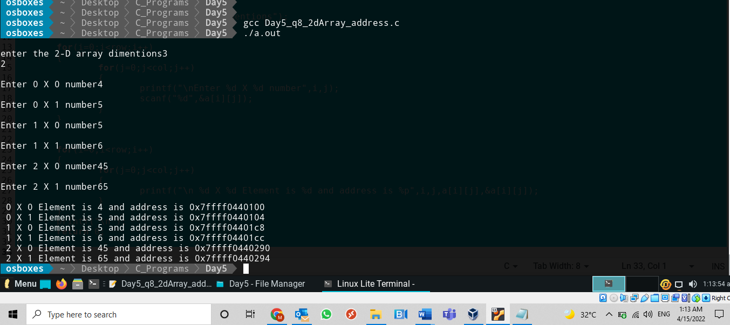

1. Write a C program to copy the elements of one 2-D array to another 2-D array.

Program:

#include<stdio.h>

int main()

{

int a[50][50],i,j;

int row,col;

int b[50][50];

printf("\nenter the 2-D array dimentions");

scanf("%d%d",&row,&col);

for(i=0;i<row;i++)

{

for(j=0;j<col;j++)

{

printf("\nEnter %d X %d number",i,j);

scanf("%d",&a[i][j]);

}

}

for(i=0;i<row;i++)

{

for(j=0;j<col;j++)

{

b[i][j]=a[i][j];

}

}

printf("\nDisplaying Copied 2D array");

for(i=0;i<row;i++)

{

for(j=0;j<col;j++)

{

printf("\n %d X %d Element is %d ",i,j,b[i][j]);

}

}

printf("\n");

return 0;

}

Output:

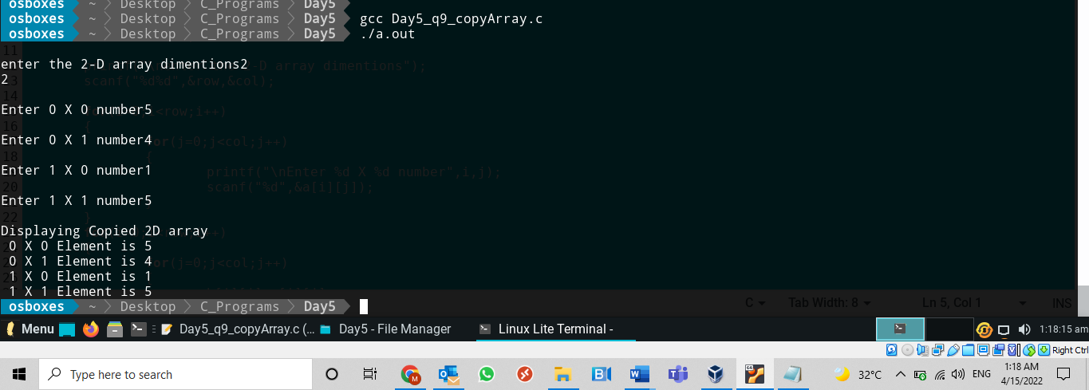

1. Write a C program to sum two 2-D matrices

Program:

#include<stdio.h>

int main()

{

int a[50][50],i,j;

int row,col;

int b[50][50],c[50][50];

printf("\nenter the 2-D array dimentions");

scanf("%d%d",&row,&col);

printf("\nEnter the First 2-D array element %d",row*col);

for(i=0;i<row;i++)

{

for(j=0;j<col;j++)

{

printf("\nEnter %d X %d number",i,j);

scanf("%d",&a[i][j]);

}

}

printf("\nEnter the Second 2-D array element %d",row*col);

for(i=0;i<row;i++)

{

for(j=0;j<col;j++)

{

printf("\nEnter %d X %d number",i,j);

scanf("%d",&b[i][j]);

}

}

for(i=0;i<row;i++)

{

for(j=0;j<col;j++)

{

c[i][j]=a[i][j]+b[i][j];

}

}

printf("\nDisplaying sum of 2D array");

for(i=0;i<row;i++)

{

for(j=0;j<col;j++)

{

printf("\n %d X %d Element is %d ",i,j,c[i][j]);

}

}

printf("\n");

return 0;

}

Output:

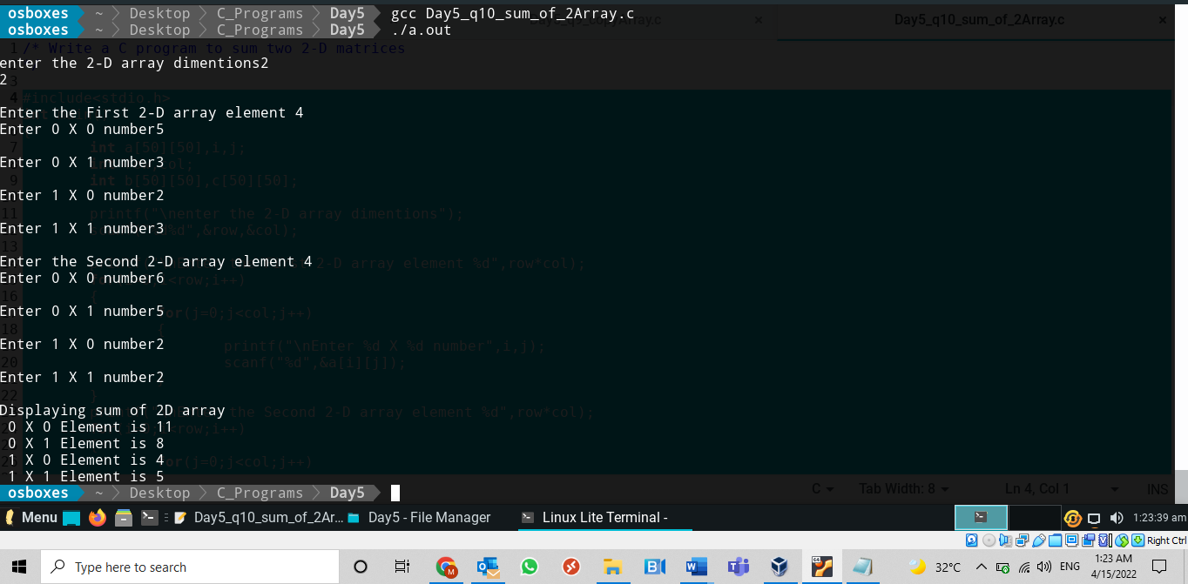

1. Write a C program to print the transpose and inverse matrices of a given matrix.

Program:

#include<stdio.h>

int main()

{

int a[10][10];

int row,col;

printf("Enter the martix order");

scanf("%d%d",&row,&col);

for(int i=0;i<row;i++)

{

for(int j=0;j<col;j++)

{

printf("Enter %d X %d th element",i+1,j+1);

scanf("%d",&a[i][j]);

}

}

printf("Entered Matrix is = \n");

for(int i=0;i<row;i++)

{

for(int j=0;j<col;j++)

{

printf("%d ",a[i][j]);

}

printf("\n");

}

printf("Transpose of matrix is = \n");

for(int i=0;i<row;i++)

{

for(int j=0;j<col;j++)

{

printf("%d ",a[j][i]);

}

printf("\n");

}

return 0;

}

Output:

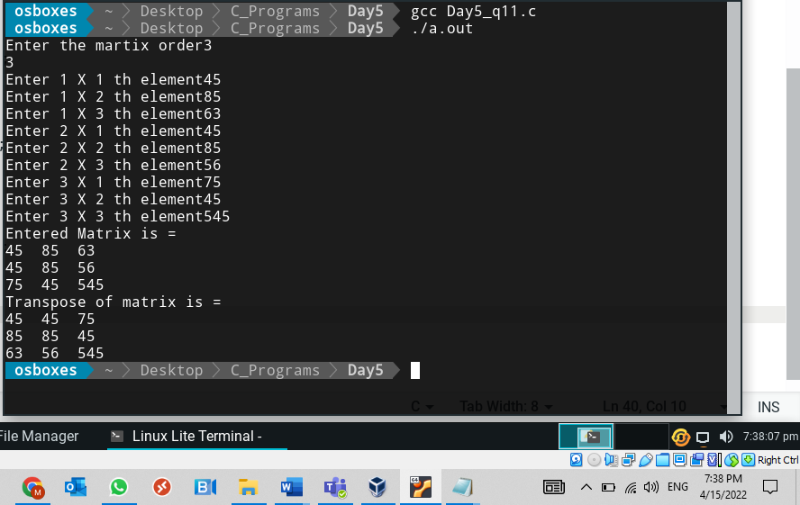

1. Write a C Program to display three-dimensional array elements with addresses

Program:

#include<stdio.h>

int main()

{

int a[50][50][50],i,j,k;

int block,row,col;

printf("\nenter the 3-D array dimentions block,rows and columns");

scanf("%d%d%d",&block,&row,&col);

for(i=0;i<block;i++)

{

for(j=0;j<row;j++)

{

for(k=0;k<col;k++)

{

printf("\nEnter %d X %d X %d number",i,j,k);

scanf("%d",&a[i][j][k]);

}

}

}

for(i=0;i<block;i++)

{

for(j=0;j<row;j++)

{

for(k=0;k<col;k++)

{

printf("\n %d X %d X %d Element is %d and address is %p",i,j,k,a[i][j][k],&a[i][j][k]);

}

}

}

printf("\n");

return 0;

}

Output:

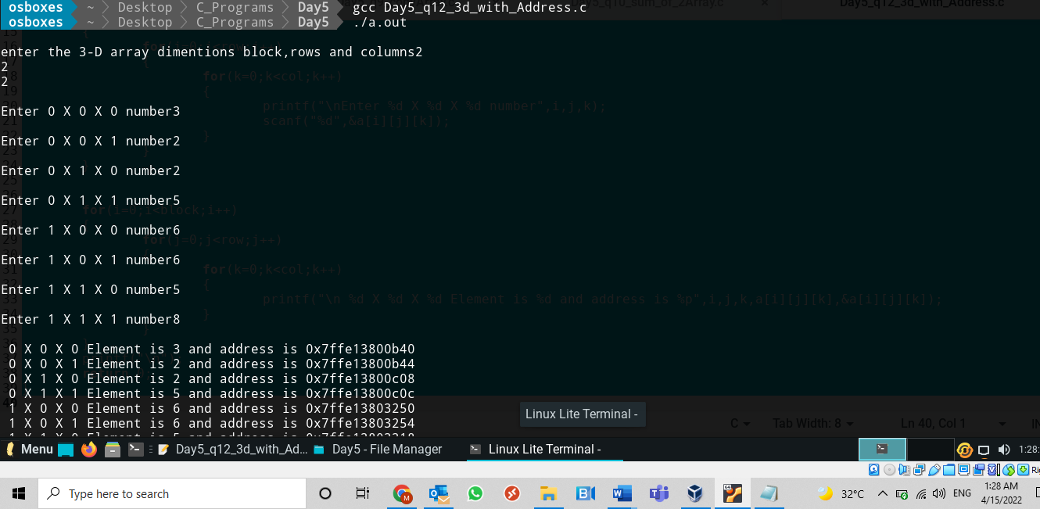

Day 6

1. Write a C program to perform the following operations on two strings using intrinsic functions.

* Concatenate two strings
* Find the length of each string
* Compare two strings
* Copy string
* Find whether string1 is the subset of the second string or not(strstr)

Program:

#include<stdio.h>

#include<string.h>

int main()

{

char str1[100],str2[100],str3[100];

int len,comp;

char *p;

printf("\nEnter first string");

scanf("%s",&str1);

printf("\nEnter second string");

scanf("%s",&str2);

//Concatnation

printf("\nConcatenate of two string = %s",strcat(str1,str2));

//Length of strings

printf("\nLength of first string = %ld",strlen(str1));

printf("\nLength of second string = %ld",strlen(str2));

//Compare two strings

comp=strcmp(str1,str2);

if(comp==0)

printf("\nStrings are equal");

else if(comp>0)

printf("\nstring 1 is greater than string 2");

else

printf("\nstring 2 is greater than string 1");

//Coping first string into str3

strcpy(str3,str1);

printf("\nFirst string copied into third string");

printf("\nThird string is = %s",str3);

//string1 is the subset of the second string or not(strstr)

puts(strstr(str1,str2));

/*if(p==0)

printf("\nString 2 is present in stirng 1 at the %s",*p);

else

printf("\nString 2 is not present in stirng 1 %s",*p);

*/

return 0;

}

Output:

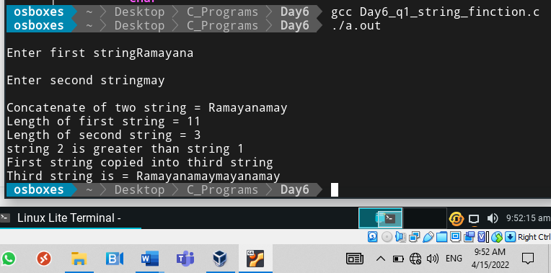

1. Write a C program to perform the following operations on two strings without using string library functions.
   * + Concatenate two strings
     + Find the length of each string
     + Compare two strings
     + Copy string
     + Reverse the string

Program:

#include<stdio.h>

char* concate(char str1[],char str2[]);

int lengthS(char str1[]);

int compare(char str1[],char str2[]);

char* CopyS(char *str);

char* reverse(char str1[]);

int main()

{

int len,comp;

char str1[50],str2[50],str3[50],*rev;

char *ptr3,*ptr1;

printf("Enter the first string");

scanf("%s",str1);

printf("Enter the Second string");

scanf("%s",str2);

ptr3=str3;

ptr1=str1;

printf("String 1 = %s \n String 2 = %s\n",str1,str2);

//Concatenate of two strings

ptr3=concate(str1,str2);

printf("\nString concate in to third string = %s",ptr3);

//Length of strings

len=lengthS(str1);

printf("\nLength of first string = %d",len);

len=lengthS(str2);

printf("\nLength of second string = %d",len);

//compare two strings

comp=compare(str1,str2);

if(comp==0)

printf("\nStrings are not equal");

else

printf("\nBoth strings are equal");

//Copy string

ptr3 = CopyS(ptr1);

printf("\nString 1 copied into string 3 = %s",ptr3);

//Reverse of string

rev=reverse(str1);

printf("\nreverse of a first string =%s",rev);

rev=reverse(str2);

printf("\nreverse of a second string =%s",rev);

return 0;

}

char* concate(char str1[],char str2[])

{

char *ptr1,*ptr2,*ptr3;

char str3[100];

int i=0,j;

ptr1=str1;

ptr2=str2;

ptr3=str3;

while(str1[i] !='\0')

{

str3[i]=str1[i];

i++;

}

j=0;

while(str2[j] !='\0')

{

str3[i]=str2[j];

i++;

j++;

}

return ptr3;

}

int lengthS(char str1[])

{

int i=0;

while(str1[i]!='\0')

{

i++;

}

return i;

}

int compare(char str1[] ,char str2[])

{

int i,count,l1,l2;

l1=lengthS(str1);

l2=lengthS(str2);

count=0;

if(l1==l2)

{

for(i=0;i<l2;i++)

{

if(str1[i]==str2[i])

{

count++;

printf("\n%c == %c",str1[i],str2[i]);

}

}

}

if(count==0)

return 0;

else

return 1;

}

char* CopyS(char *str)

{

return str;

}

char* reverse(char str1[])

{

char rev[50],*ptr;

int i,len,j=0;

len=lengthS(str1);

j=0;

for(i=len-1;i>=0;i--)

{

rev[j]=str1[i];

j++;

}

ptr=&rev[0];

return ptr;

}

Output:

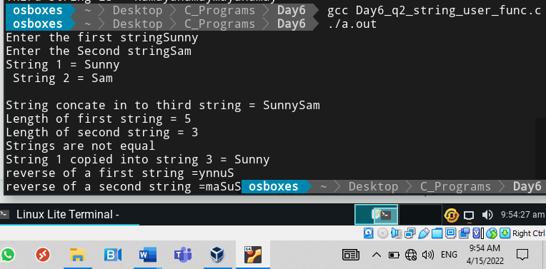

1. Write a program to convert lower case string to upper case string and vice versa

Program:

#include<stdio.h>

#include<ctype.h>

#include<string.h>

int main()

{

char a[50];

char ch;

int i,n;

printf("Enter the string");

scanf("%s",a);

n=strlen(a);

for(i=0;i<n;i++)

{

if(islower(a[i])!=0)

{

a[i]=toupper(a[i]);

}

else

a[i]=tolower(a[i]);

}

printf("String after conversion is %s",a);

return 0;

}

Output:

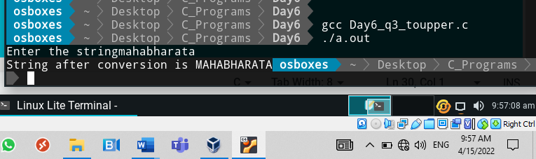

1. Write a program to print out all rotations of a string typed in. For eg:if the input is “Space”, the output should be: space paces acesp cespa espac.

Program:

#include<stdio.h>

#include<string.h>

int main()

{

int i,j,n;

char str[50],*ptr;

printf("Enter the string");

scanf("%s",str);

n=strlen(str);

ptr=str;

printf("%s => %d => %s",str,n,ptr);

for(i=0;i<n;i++)

{

printf("\n => %s",ptr++);

for(j=0;j<i;j++)

{

printf("%c",str[j]);

}

}

return 0;

}

Output:

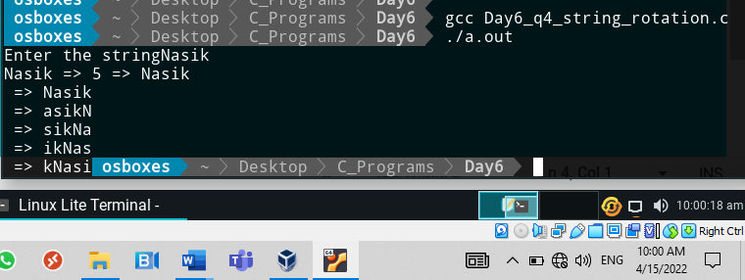

1. Write a C Program to Count the Number of Vowels, Consonants, digits and remaining characters in given string

Program:

#include<stdio.h>

#include<ctype.h>

#include<string.h>

int main()

{

int n,i=0,vowel_count=0,conso_count=0,digit_count=0,remain_count=0;

char ch[50];

printf("enter the string ");

scanf("%s",ch);

n=strlen(ch);

for(i=0;i<n;i++)

{

if(isalpha(ch[i])!=0)

{

if(ch[i]=='a'||ch[i]=='A'||ch[i]=='e'||ch[i]=='E'||ch[i]=='i'||ch[i]=='I'||ch[i]=='o'||ch[i]=='O'||ch[i]=='u'||ch[i]=='U')

{

vowel_count++;

}

else

{

conso_count++;

}

}

else if(isdigit(ch[i])!=0)

{

digit_count++;

}

else

{

remain_count++;

}

}

printf("\nCount of Vowels = %d",vowel_count);

printf("\nCount of Consonants = %d",conso_count);

printf("\nCount of Digit = %d",digit_count);

printf("\nCount of remaining charators = %d",remain_count);

return 0;

}

Output:

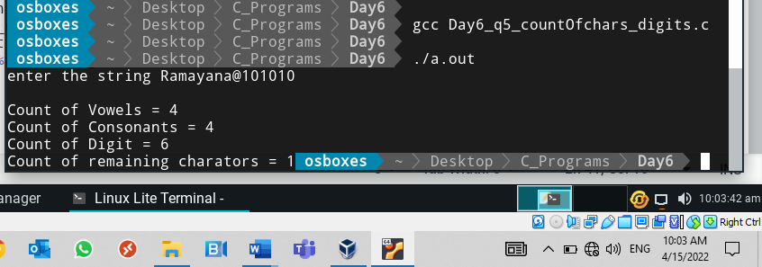

1. Write a C program to remove characters in a given string except alphabets

Program:

#include<stdio.h>

#include<ctype.h>

int main()

{

int i,j;

char str[50],s[50];

printf("Enter the string");

scanf("%s",str);

for(i=0;str[i]!='\0';i++)

{

if(isalpha(str[i])!=0)

{

s[j]=str[i];

j++;

}

}

printf("After character removing the string is %s",s);

return 0;

}

Output:

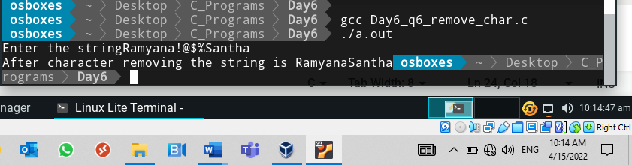

Day 7

1. Write a C program that declares and initializes (to any value you like) a char, an int, a double and a float. Your program should then print the address of, and value stored in, each of the variables.

Use the format string "%u" [%p in hex] to print the addresses as unsigned integers. Hint: You can use the character “&” to find addresses

Program:

#include<stdio.h>

int main()

{

int a=100;

char ch = 'B';

double d=45.897;

float f=87.954;

printf("\nValue of integer a = %d and address is %p",a,&a);

printf("\nValue of char ch = %c and address is %p",ch,&ch);

printf("\nValue of Doulble d = %lf and address is %p",d,&d); // lf used to print double data type

printf("\nValue of Float f = %f and address is %p",f,&f);

return 0;

}

Output:

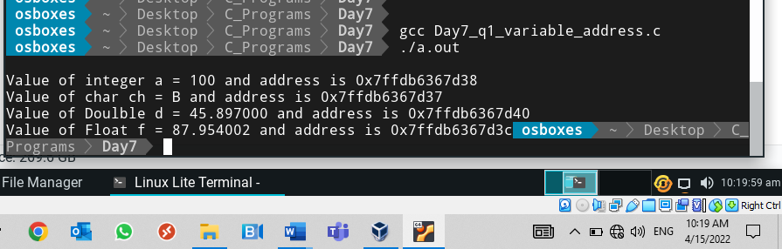

1. Write a C program to declare an integer and an integer pointer to it. Initialize the integer variable. Print the value of the int variable using pointer variable.

Hint: You can use dereferencing operator *.

Program:

#include<stdio.h>

int main()

{

int a;

int *ptr;

a=100;

ptr=&a;

printf("Values of integer variable is =%d",*ptr);

return 0;

}

Output:

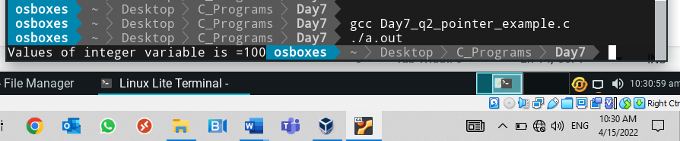

Day 8:

1. Write a program to perform the swap operation. Write a swap function and use call by reference.

Program:

#include<stdio.h>

int swap(int *a,int *b);

int main()

{

int a,b;

printf("\nPlease enter to swap the numbers");

scanf("%d%d",&a,&b);

printf("\n value of a = %d",a);

printf("\n Value of b = %d",b);

swap(&a,&b);

return 0;

}

int swap(int *a,int *b)

{

int c;

c=*a;

*a=*b;

*b=c;

printf("\n Values after swap:");

printf("\n Value of a = %d",*a);

printf("\n Value of b = %d\n",*b);

return 0;

}

Output:

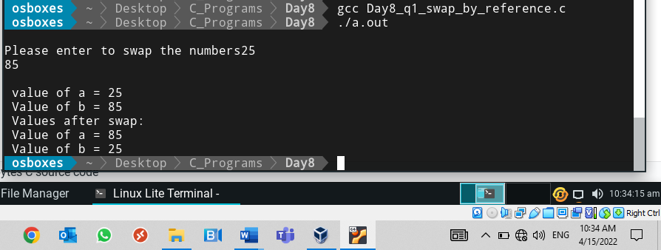

1. Write a C program to read through an array of any type using pointers. Copy the elements of the first array to second array using pointers.

Hint: a[i] = *(a+i)

Program:

#include<stdio.h>

int main()

{

int a[50],b[50],i,n;

int *ptr;

int *ptrb;

printf("enter the limit of an array");

scanf("%d",&n);

ptr=&a[0];

for(i=0;i<n;i++)

{

printf("Enter %d element",i+1);

scanf("%d",&*(ptr+i));

}

ptrb=&b[0];

for(i=0;i<n;i++)

{

*(ptrb + i)= *(ptr+i);

}

printf("\nValues of B arrary as below :");

for(i=0;i<n;i++)

{

printf(" \n%d Value of array is %d",i+1,*(ptrb+i));

}

return 0;

}

Output:

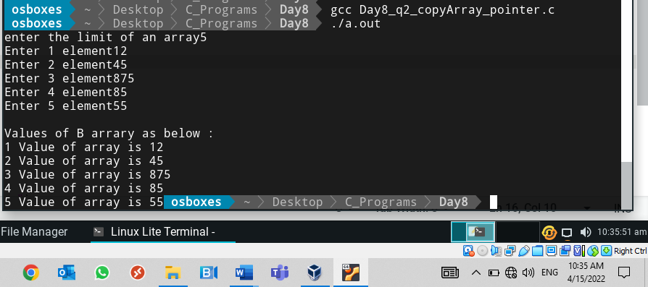

1. Write a program in C to store n elements (read from standard input) in an array and print the elements using pointer

Program:

#include<stdio.h>

int main()

{

int a[50],i,n;

int *ptr;

printf("enter the limit of an array");

scanf("%d",&n);

ptr=&a[0];

for(i=0;i<n;i++)

{

printf("Enter %d element",i+1);

scanf("%d",&*(ptr+i));

}

printf("\nValues of arrary as below :");

for(i=0;i<n;i++)

{

printf(" \n%d Value of array is %d",i+1,*(ptr+i));

}

return 0;

}

Output:

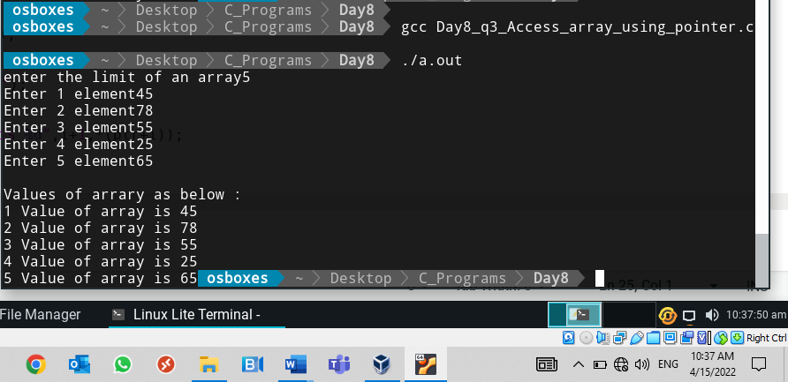

1. A C program contains the following declaration

int x[8]= {10,20,30,40,50,60,70,80};

What is the value of x? (and understand)

What is the value of (x+2)? (and understand)

What is the value of *x?

What is the value of (*x+2)?

What is the value of *(x+2)?.

Program:

#include<stdio.h>

int main()

{

int y[8]={10,20,30,40,50,60,70,80};

int *x;

printf("\n%u",y); //Address of array

printf("\n%u",y+2);

x=&y[0];

printf("\nValues of an array using pointers\n");

printf("\n%u",*x);//Values of an array 10

printf("\n%u",(*x+2));// Values 10+2

printf("\n%u",*(x+2));//Value 30

return 0;

}

Output:

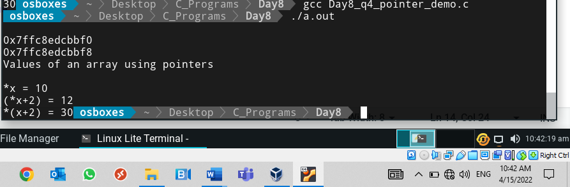

1. C program to search element in array (1-D)using pointers

Program:

#include<stdio.h>

int main()

{

int a[50],i,target,n,count;

int *ptr;

printf("\nenter the array limit");

scanf("%d",&n);

for(i=0;i<n;i++)

{

printf("\nenter %d th number",i+1);

scanf("%d",&a[i]);

}

printf("\nenter the target element you want search");

scanf("%d",&target);

ptr=&a[0];

count=0;

for(i=0;i<n;i++)

{

if(target==*(ptr+i))

{

count++;

break;

}

}

if(count==0)

printf("Element not found in array");

else

printf("Element found at %d position",i+1);

return 0;

}

Output:

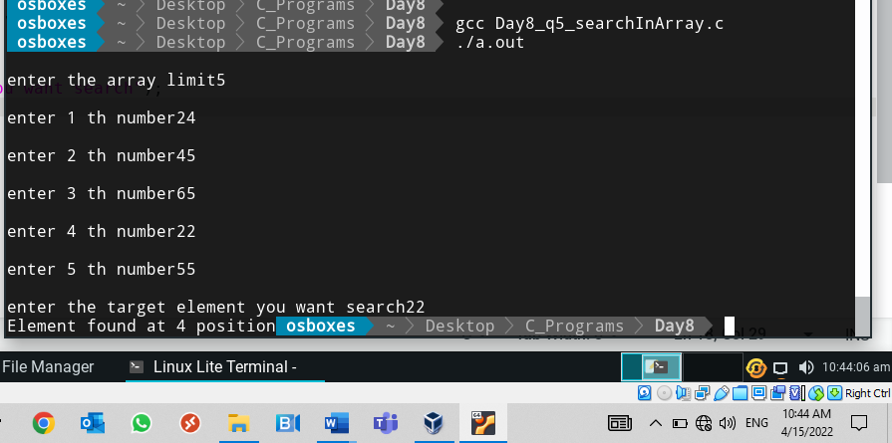

1. Write a C program to print all elements of two dimensional array using pointers.

Program:

#include<stdio.h>

int main()

{

int a[50][50],i,j;

int row,col;

int *ptr;

printf("\nenter the 2-D array dimentions");

scanf("%d%d",&row,&col);

for(i=0;i<row;i++)

{

ptr=&a[i][0]; /*assigned next row address because array size is but limit less than 50 so need to find the next row so intialize the next row can find nexr row using the array size here array size is 50X50 50*4 next row is exact address+50 or address+200bytes(50*4) */

for(j=0;j<col;j++)

{

printf("\nEnter %d X %d number",i,j);

scanf("%d",&*(ptr+j));

}

}

for(i=0;i<row;i++)

{

ptr=&a[i][0];

for(j=0;j<col;j++)

{

printf("\n %d X %d Element is %d and address is %u",i,j,*(ptr+j),ptr+j);

}

}

printf("\n");

return 0;

}

Output:

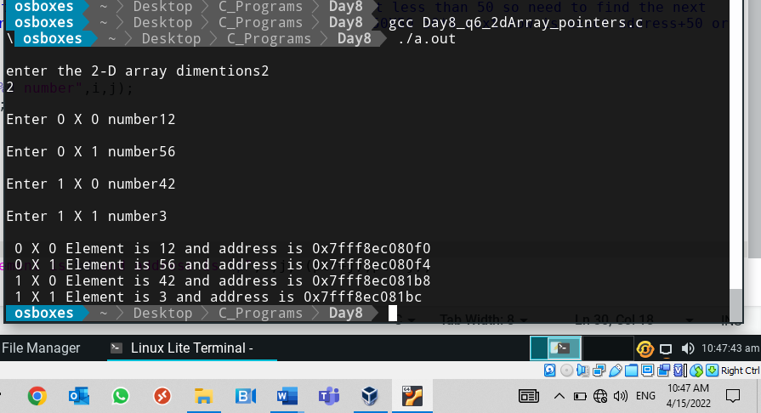

1. Implement string library functions strlen, strcpy, strcat, strcmp with same return values and all error handling features using pointers.

Program:

#include<stdio.h>

char* concate(char str1[],char str2[]);

int lengthS(char str1[]);

int compare(char str1[],char str2[]);

char* CopyS(char *str);

int main()

{

int len,comp;

char str1[50],str2[50],str3[50],*rev;

char *ptr3,*ptr1;

printf("Enter the first string");

scanf("%s",str1);

printf("Enter the Second string");

scanf("%s",str2);

ptr3=str3;

ptr1=str1;

printf("String 1 = %s \n String 2 = %s\n",str1,str2);

//Concatenate of two strings

ptr3=concate(str1,str2);

printf("\nString concate in to third string = %s",ptr3);

//Length of strings

len=lengthS(str1);

printf("\nLength of first string = %d",len);

len=lengthS(str2);

printf("\nLength of second string = %d",len);

//compare two strings

comp=compare(str1,str2);

if(comp==0)

printf("\nStrings are not equal");

else

printf("\nBoth strings are equal");

//Copy string

ptr3 = CopyS(ptr1);

printf("\nString 1 copied into string 3 = %s",ptr3);

return 0;

}

char* concate(char str1[],char str2[])

{

char *ptr1,*ptr2,*ptr3;

char str3[100];

int i=0,j;

ptr1=str1;

ptr2=str2;

ptr3=str3;

while(str1[i] !='\0')

{

str3[i]=str1[i];

i++;

}

j=0;

while(str2[j] !='\0')

{

str3[i]=str2[j];

i++;

j++;

}

return ptr3;

}

int lengthS(char str1[])

{

int i=0;

while(str1[i]!='\0')

{

i++;

}

return i;

}

int compare(char str1[] ,char str2[])

{

int i,count,l1,l2;

l1=lengthS(str1);

l2=lengthS(str2);

count=0;

if(l1==l2)

{

for(i=0;i<l2;i++)

{

if(str1[i]==str2[i])

{

count++;

printf("\n%c == %c",str1[i],str2[i]);

}

}

}

if(count==0)

return 0;

else

return 1;

}

char* CopyS(char *str)

{

return str;

}

Output:

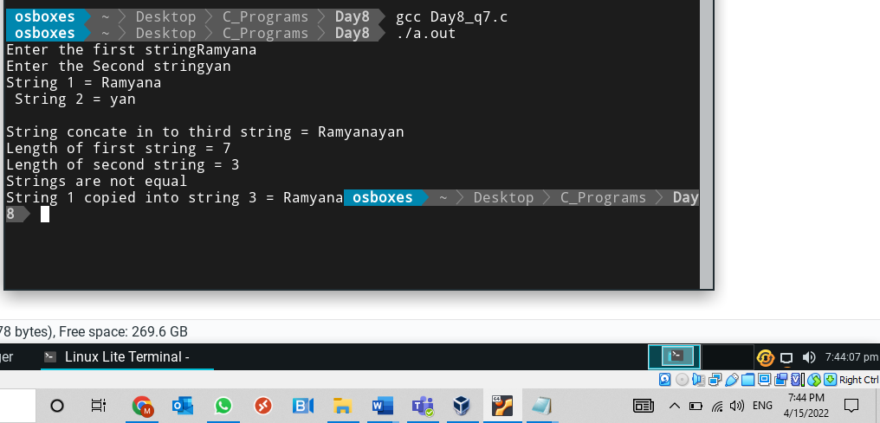

1. Write a C program to find reverse of a string using pointers.

Program:

#include<stdio.h>

#include<string.h>

int main()

{

char ch[50];

char *ptr;

int len,i;

ptr=&ch[0];

printf("\nEnter the string");

scanf("%s",ch);

len=strlen(ch);//printf("%s",ch);

printf("Reverse of String is :");

for(i=len;i>=0;i--)

{

printf("%c",*(ptr+i));

}

return 0;

}

Output:

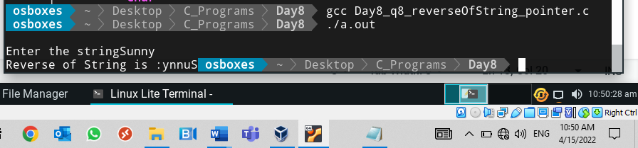

1. Write a program in C to count the number of vowels and consonants in a string using a pointer.

Program:

#include<stdio.h>

#include<string.h>

int main()

{

char ch[50],vowel_count,consonants_count;

char *ptr;

int i;

ptr =&ch;

printf("Enter the string");

gets(ch);

printf("string is %s",ch);

vowel_count=0;

consonants_count=0;

for(i=0;i<strlen(ch);i++)

{

if(ch[i]=='a'||ch[i]=='A'||ch[i]=='e'||ch[i]=='E'||ch[i]=='i'||ch[i]=='I'||ch[i]=='o'||ch[i]=='O'||ch[i]=='u'||ch[i]=='U')

{

vowel_count++;

}

else

consonants_count++;

}

printf("\n Count of Vowals =%d and Count of Consonants =%d",vowel_count,consonants_count);

return 0;

}

Output:

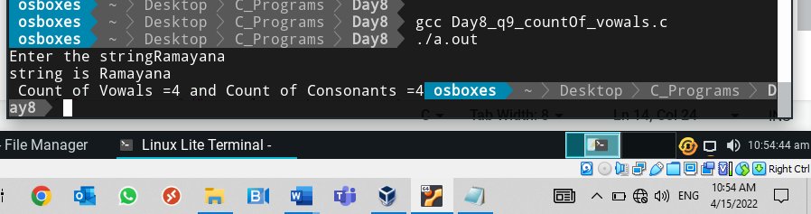

Day 9

1. **Lower case to Uppercase:** Convert a string from lower case to uppercase using pointers. Write a separate function to do the conversion. Do not use intrinsic functions

Program:

#include<stdio.h>

char toupperchar(char ch);

int main()

{

char str[50];

int i=0;

printf("enter the string");

scanf("%s",str);

while(*(str+i)!='\0')

{

*(str+i)=toupperchar(*(str+i));

i++;

}

printf("your string is %s",str);

return 0;

}

char toupperchar(char ch)

{

int a;

a=ch;

if(a>=97 && a<=122)

{

a=a-32;

return a;

}

else

return ch;

}

Output:

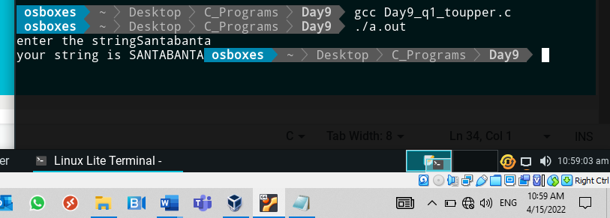

1. **Uppercase to Lower case:** Convert a string from upper case to lowercase using pointers. Write a separate function to do the conversion. Do not use intrinsic 0f functions

Program:

#include<stdio.h>

char tolowerchar(char ch);

int main()

{

char str[50];

int i=0;

printf("enter the string");

scanf("%s",str);

while(*(str+i)!='\0')

{

*(str+i)=tolowerchar(*(str+i));

i++;

}

printf("your string is %s",str);

return 0;

}

char tolowerchar(char ch)

{

int a;

a=ch;

if(a>=65 && a<=90)

{

a=a+32;

return a;

}

else

return ch;

}

Output:

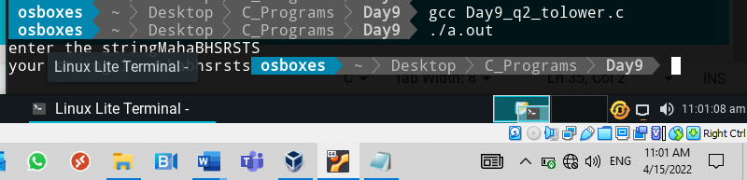

1. Write a C program to demonstrate double pointer.

(Practice all double pointer programs covered in class ppt)

Program:

#include<stdio.h>

int main()

{

int a=10;

int *n,**m;

n=&a;

m=&n;

printf(" Value of a unsing variable =%d",a);

printf(" Value of a unsing pointer =%d",*n);

printf(" Value of a unsing double pointer =%d",**m);

return 0;

}

Output:

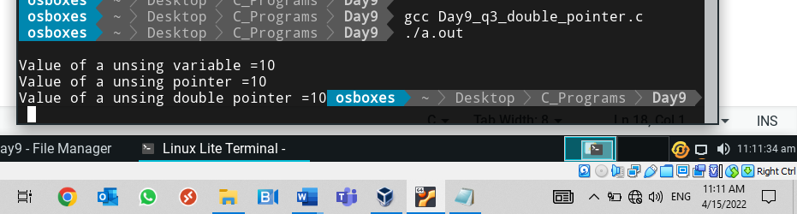

1. Write a program to read n number of strings using two-dimensional character array, sort them and display the sorted list of strings on the screen. (use strcmp and strcpy library functions)

Program:

#include<stdio.h>

#include<string.h>

int main()

{

char a[50][50],b[50];

int i,j,k,n;

char *ap,*bp;

printf("\nenter the array limit");

scanf("%d",&n);

for(i=0;i<n;i++)

{

printf("\nenter %d string",i+1);

scanf("%s",*(a+i));

}

ap=a[0];

bp=b;

for(j=0;j<n;j++)

{

strcpy(bp,a[j]);

printf("smallest= %s",bp);

for(k=j;k<n;k++)

{

if(strcmp(a[j],a[k])<0)

{

strcpy(bp,a[j]);

strcpy(a[j],a[k]);

strcpy(a[k],bp);

}

}

}

printf("\nsorted array given as below :");

for(i=0;i<n;i++)

{

printf("\n %d element is %s",i+1,a[i]);

}

return 0;

}

Output:

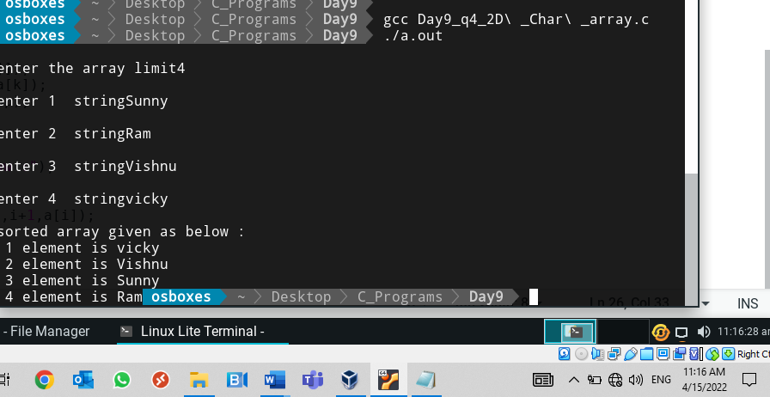

1. Write a C program with a function any (s1, s2). This function returns the first location (index of location) in the string s1 which matches with any string in s2 otherwise return NULL. Do not use string library functions (strstr).

Program:

#include<stdio.h>

#include<string.h>

int any(char *s1,char *s2);

int main()

{

char str1[50],str2[50];

int n;

printf("Enter the first string");

scanf("%s",str1);

printf("Enter the second string");

scanf("%s",str2);

n=any(str1,str2);

if(n==0)

printf("String not found");

else

printf("String found at %d position",n);

return 0;

}

int any(char *s1,char *s2)

{

int s1n,s2n,i,j,pos,count=0,k;

char s3[50];

s1n=strlen(s1);

s2n=strlen(s2);

pos=0;

printf("\ns1n = %d \ts2n = %d",s1n,s2n);

for(i=0;i<s1n;i++)

{

k=i;

count=0;

for(j=0;j<s2n;j++)

{

s3[j]=s1[k];

k++;

}

printf("\nthird string = %s",s3);

for(j=0;j<s2n;j++)

{

printf("comparing %c== %c",s2[j],s3[j]);

if(s2[j]!=s3[j])

break;

else

count++;

}

printf("\ncount =%d \t position =%d",count,i);

if(count==s2n)

return i+1;

}

return 0;

}

Output:

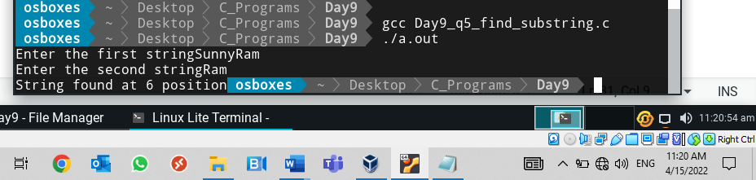

1. A C program contains the following declaration

float table[2][3] = { { 1.1,1.2,1.3},{2.1,2.2,2.3}};

a) What is the meaning of a table?

b) What is the meaning of (table+1)?

c) What is the meaning of *(table+1)?

d) What is the meaning of (*(table+1)+1)?

e) What is the meaning of (*(table)+1)?

f) What is the value of *(*(table+1) +1)?

g) What is the value of *(*(table)+1)?

h) What is the value of *(*(table+1)?

i) What is the value of *(*(table) + 1)+1?

Program:

#include<stdio.h>

int main()

{

float table[2][3]={{1.1,1.2,1.3},{2.1,2.2,2.3}};

int i,j,n;

//a) What is the meaning of a table?

//It's a 2D float array with 2X3 order

//b) What is the meaning of (table+1)?

//it' points to the base address of 1st row of the table

printf("\nAdrress of table+1 = %p",(table+1));

//c) What is the meaning of *(table+1)?

//It' points to the base address of 0th element of first row array

printf("\nAdrress of (table+1) = %p",*(table+1));

//d) What is the meaning of (*(table+1)+1)?

//it's points to the base address of 1st element of first row array (1X1 element) because * operator not used

printf("\nAdrress of *(table+1)+1 = %p",*(table+1)+1);

//e) What is the meaning of (*(table)+1)?

//this is points to the address of 0th row and first colomn of array element

printf("\nAdrress of (*(table)+1) = %p",*(table+1)+1);

//f) What is the value of *(*(table+1) +1)?

//This is points ot the 1st row *(table+1) and +1 so column also increased and * used so element of the 1X1 i.e.value 2.2

printf("\nValue of *(*(table+1) +1)= %f",*(*(table+1) +1));

//g) What is the value of *(*(table)+1)?

//this is points to the 0th row 1 column i.e. value 1.2

printf("\nValue of *(*(table)+1= %f",*(*(table)+1));

//h) What is the value of *(*(table+1)?

//this will points to the 1 row 0 th column 1.e.value 2.1

printf("\nValue of *(*(table+1)= %f",*(*(table+1)));

//i) What is the value of *(*(table) + 1)+1?

//This is points to the 0 row 1 colum and +1 so value 1.2+1 = 2.2

printf("\nValue of *(*(table) + 1)+1= %f",*(*(table) + 1)+1);

return 0;

}

Output:

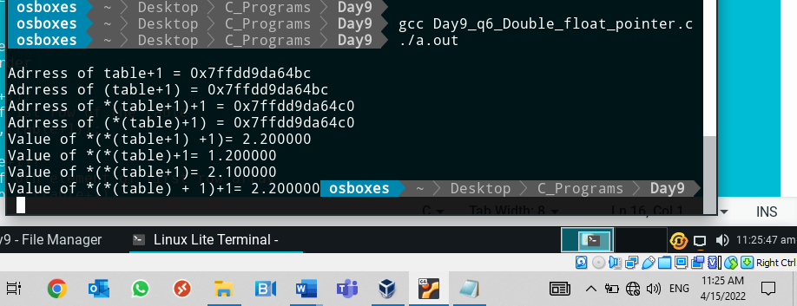

1. A C program contains the following declaration

char *color[6] = {“red”, “green”, “blue”, “white”, “black”, “yellow”};

a. What is the meaning of color?

b. What is the meaning of (color+2);

c. What is the value of *color?

d. What is the value of *(color+2)?

e. How do color[5] and *(color + 5) differ?.

Program

#include<stdio.h>

int main()

{

char *color[6] = {"red","green","blue","white","black","yellow"};

//a. What is the meaning of color?

//it's array pointer variable of the type char with size of 6 elements

//b. What is the meaning of (color+2);

//this points to the address of 2nd string of array i.e address of blue

printf("\nAddress of the (color+2) = %p",(color+2));

//c. What is the value of *color?

//this is points to the 0th element of array i.e.red

printf("\nValue of the *color = %s",*color);

//d. What is the value of *(color+2)

//this is points to the 2nd element of array i.e.blue

printf("\nValue of the *(color +2) = %s",*(color+2));

//e. How do color[5] and *(color + 5) differ?.

//color[5] - it's pointing the 6 th element by using the array indexing

//*(color+5) - it's pointing to the 6th element by using the pointer arithmatic and dereferenceing

printf("\nValue of the color[5] = %s",color[5]);

printf("\nValue of the *(color + 5) = %s",*(color+5));

return 0;

}

Output:

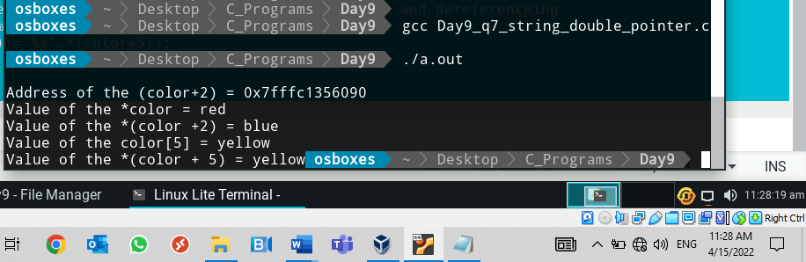

Day 10

1. Student record management System

Write a C program to keep records and perform statistical analysis for a class of 5 students. The information of each student contains:

* RollNumber
* Name
* Sex 9848252498 javademystifiedbyssr
* Exam Score.

**Do following operations**

1. Add student records

2. View all student records

3. Show student who gets the maximum score

4. Show student who gets the minimum score

Program:

#include<stdio.h>

#include<stdlib.h>

#include<string.h>

struct student

{

int RollNumber;

char Name[20];

char gender[10];

float score;

};

int main()

{

int n,i,j;

int ch;

float max=0.0f,min=100.0f;

char maxName[20],minName[20];

struct student s[5];

n=0;

for(i=0;i<100;i++)

{

printf("\nPlease select your choice");

printf("\n1.Add student record");

printf("\n2.View all student records");

printf("\n3.Student of maximum score");

printf("\n4.Student of minimum score");

printf("\n5.Exit\n");

scanf("\n %d",&ch);

switch(ch)

{

case 1: if(n==5)

{

printf("Student records are full you can not add further");

break;

}

else

{

printf("\nplease enter the student roll number\t");

scanf("%d",&s[n].RollNumber);

printf("\nplease enter the student Name\t");

scanf("%s",s[n].Name);

printf("\nplease enter the student Gender\t");

scanf("%s",s[n].gender);

printf("\nplease enter the student score\t");

scanf("%f",&s[n].score);

n++;

}

break;

case 2: if(n==0)

{

printf("Student records are null");

break;

}

else

{

for(j=0;j<n;j++)

{

printf("\n Student roll number = %d",s[j].RollNumber);

printf("\n\t\t Name =%s",s[j].Name);

printf("\n\t\t Gender =%s",s[j].gender);

printf("\n\t\t Score =%f",s[j].score);

}

}

break;

case 3: if(n==0)

{

printf("Student records are null");

break;

}

else

{

for(j=0;j<n;j++)

{

if(s[j].score>max)

{

max=s[j].score;

strcpy(maxName,s[j].Name);

}

}

printf("\n \tTopper is %s \t with %f score",maxName,max);

}

break;

case 4:

if(n==0)

{

printf("Student records are null");

break;

}

else if(n==1)

{

printf("only one student in class");

break;

}

else

{

for(j=0;j<n;j++)

{

if(s[j].score<min)

{

min=s[j].score;

strcpy(minName,s[j].Name);

}

}

printf("\n \t %s has scored %f which lowest in class",minName,min);

}

break;

case 5:exit(0);

}

}

return 0;

}

Output:

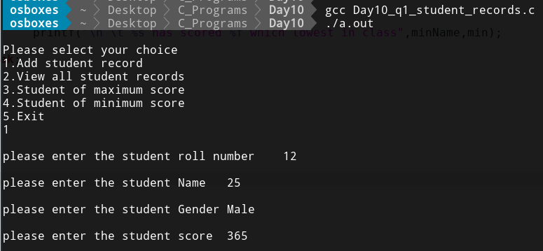

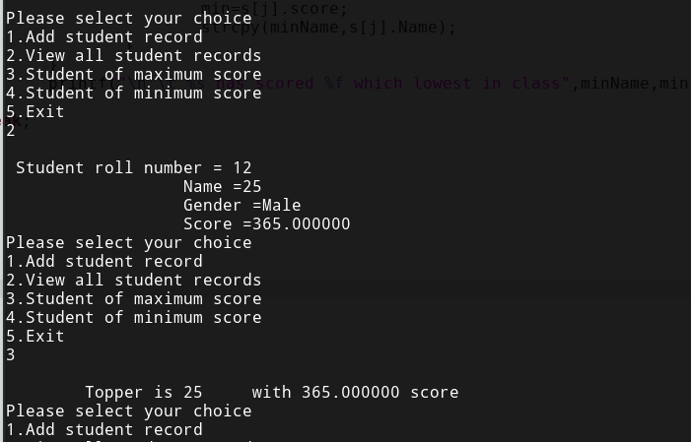

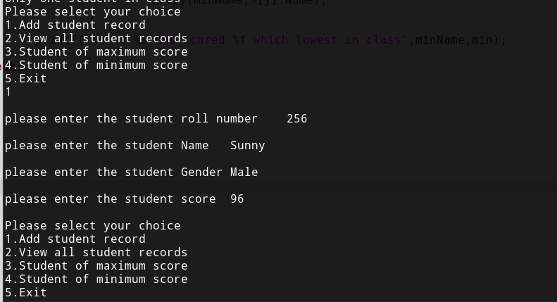

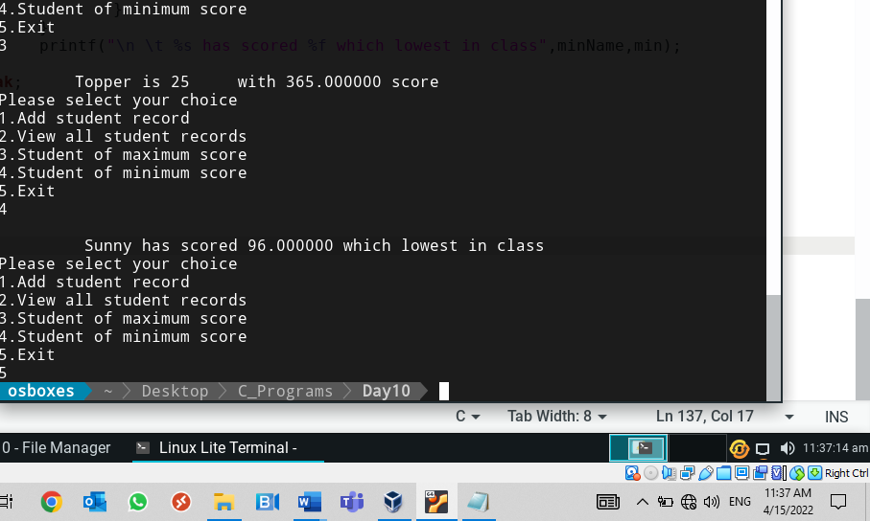

1. Define structure with two members (one int and other char). Also define union with two members (one int and other char). Print the sizes of structure and union in number of bytes. Initialize union/structures members and print.

Program:

#include<stdio.h>

struct structExample

{

int a;

char c;

};

union unionExample

{

int n;

char ch;

};

int main()

{

struct structExample e1;

union unionExample e2;

//structure initialisation

e1.a=10;

e1.c='A';

printf("\nValue of structure A = %d",e1.a);

printf("\nValue of structure C = %c",e1.c);

printf("\nSize of struct = %ld ",sizeof(e1)); // 8 bytes due to the structure padding

//union intitalisation

e2.n=1000;

printf("\nValue of union N = %d",e2.n);

e2.ch='B';

printf("\nValue of union Ch = %c",e2.ch);

printf("\nSize of union = %ld ",sizeof(union unionExample));

return(0);

}

Output:

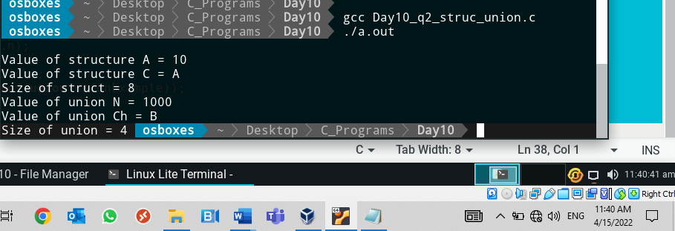

1. Define a structure “complex” (use typedef) to read two complex numbers and perform addition, subtraction of these two complex numbers and display the result

Program:

#include<stdio.h>

typedef struct complex

{

int num1;

int num2;

}com;

int main()

{

com c1,c2;

int addreal,subreal;

int addimg,subimg;

printf("\nEnter the first complex number");

printf("\n\treal number = ");

scanf("%d",&c1.num1);

printf("\n\tEnter the imaginery number(only num) * i = ");

scanf("%d",&c1.num2);

printf("\nEnter the Second complex number");

printf("\n\treal number = ");

scanf("%d",&c2.num1);

printf("\n\tEnter the imaginery number (only num) * i= ");

scanf("%d",&c2.num2);

addreal=c1.num1+c2.num1;

subreal=c1.num1-c2.num1;

addimg=c1.num2+c2.num2;

subimg=c1.num2-c2.num2;

printf("\naddition of two complext number =\t%d+%di ",addreal,addimg);

printf("\nSubstraction of two complext number =\t%d-(%di) ",subreal,subimg);

return 0;

}

Output:

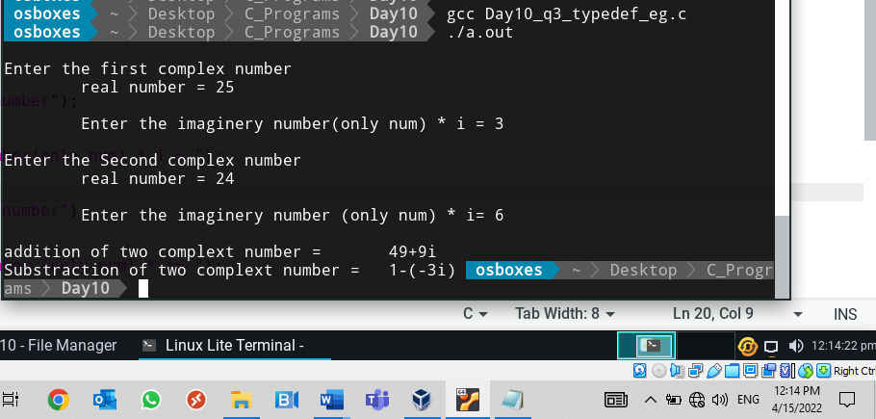

1. Write a program to read and print an Employee’s details using Structure.

Use array of structures and pointer to the array of structures concepts.

Program:

#include<stdio.h>

#include<stdlib.h>

struct employee

{

int eno;

char ename[20];

float esal;

};

int main()

{

struct employee e[10];

int i,n,j;

int ch;

struct employee *ptr,*ptr1;

n=0;

ptr=e;

for(i=0;i<100;i++)

{

printf("\nEnter your choice");

printf("\n\t1.Add Employee");

printf("\n\t2.view Employee details");

printf("\n\t3.Exit\n");

scanf("%d",&ch);

switch(ch)

{

case 1 : if(n>=10)

{

printf("\nEmaployee details are full");

break;

}

else

{

printf("\n\tplease enter employee ID");

scanf("%d",&ptr->eno);

printf("\n\tplease enter employee Name");

scanf("%s",ptr->ename);

printf("\n\tplease enter employee salary");

scanf("%f",&ptr->esal);

ptr++;

n++;

}

break;

case 2 : if(n==0)

{

printf("\nEmaployee details are not updated yet");

break;

}

else

{

ptr1=e;

for(j=0;j<n;j++)

{

printf("\n\tplease enter employee ID = %d",ptr1->eno);

printf("\n\t\tplease enter employee Name = %s",ptr1->ename);

printf("\n\t\tplease enter employee salary = %f",ptr1->esal);

ptr1++;

}

}

break;

case 3 :exit(0);

}

}

return 0;

}

Output:

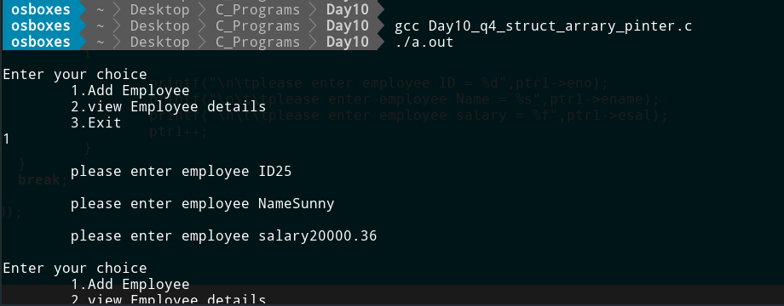

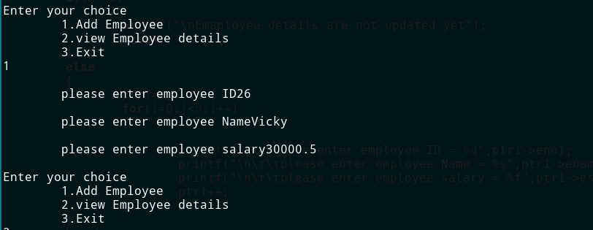

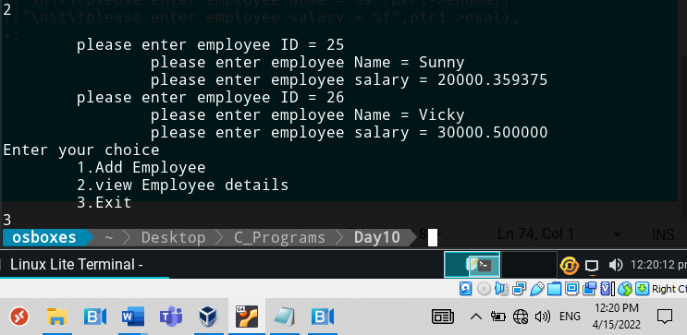

Day 11

1. Write a program to read and print an Employee’s details using Structure.

Use array of structures and pointer to the array of structures concepts.

Program:

#include<stdio.h>

#include<stdlib.h>

struct employee

{

int eno;

char ename[20];

float esal;

};

int main()

{

struct employee e[10];

int i,n,j;

int ch;

struct employee *ptr,*ptr1;

n=0;

ptr=e;

for(i=0;i<100;i++)

{

printf("\nEnter your choice");

printf("\n\t1.Add Employee");

printf("\n\t2.view Employee details");

printf("\n\t3.Exit\n");

scanf("%d",&ch);

switch(ch)

{

case 1 : if(n>=10)

{

printf("\nEmaployee details are full");

break;

}

else

{

printf("\n\tplease enter employee ID");

scanf("%d",&ptr->eno);

printf("\n\tplease enter employee Name");

scanf("%s",ptr->ename);

printf("\n\tplease enter employee salary");

scanf("%f",&ptr->esal);

ptr++;

n++;

}

break;

case 2 : if(n==0)

{

printf("\nEmaployee details are not updated yet");

break;

}

else

{

ptr1=e;

for(j=0;j<n;j++)

{

printf("\n\tplease enter employee ID = %d",ptr1->eno);

printf("\n\t\tplease enter employee Name = %s",ptr1->ename);

printf("\n\t\tplease enter employee salary = %f",ptr1->esal);

ptr1++;

}

}

break;

case 3 :exit(0);

}

}

return 0;

}

Output:

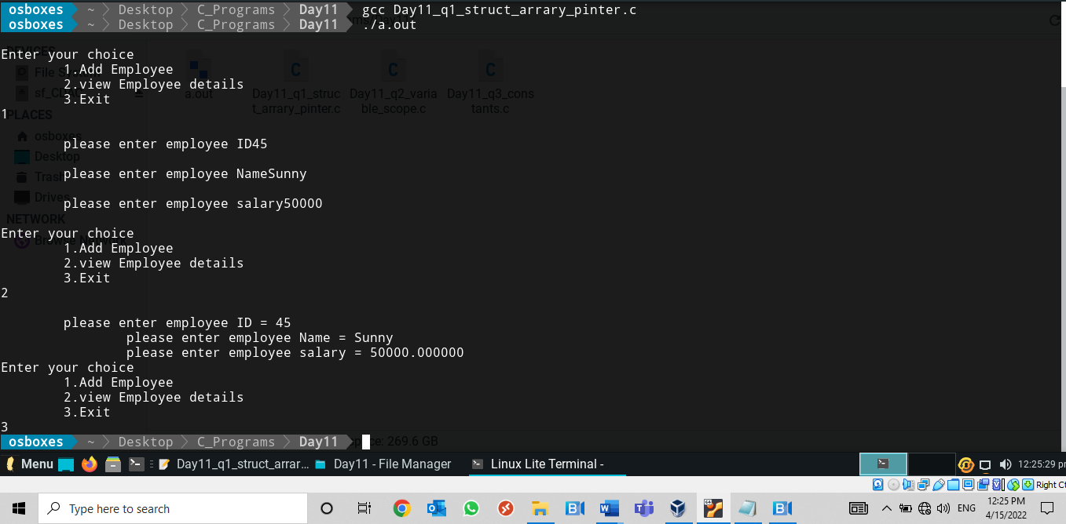

1. Write c programs to demonstrate various storages classes

Program:

#include<stdio.h>

void fun_var(int i);

int externcount;

int main()

{

int i,count=0;

auto int autocount=0;

register int registercount=0;

int externcount=95;// creates the new local variable

for(i=0;i<5;i++)

{

printf("\n itteration %d- value of auto count in main = %d",i+1,autocount);

printf("\n itteration %d- value of register count in main= %d",i+1,registercount);

fun_var(i+1);

printf("\n itteration %d- value of extern count in main = %d",i,externcount);

externcount++;

autocount++;

registercount++;

printf("\n");

}

return 0;

}

void fun_var(int i)

{

auto int autocount;

register int registercount;

static int statcount;

extern int externcount; //denote to globle variable

printf("\n itteration %d- value of auto count in function= %d",i,autocount);

printf("\n itteration %d- value of register count in function= %d",i,autocount);

printf("\n itteration %d- value of static count in function= %d",i,statcount);

printf("\n itteration %d- value of extern count in function = %d",i,externcount);

externcount++;

statcount++;

}

Output:

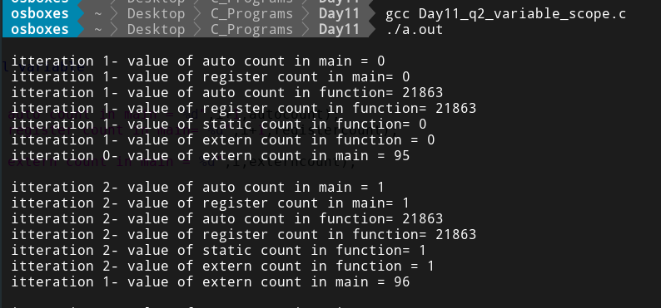

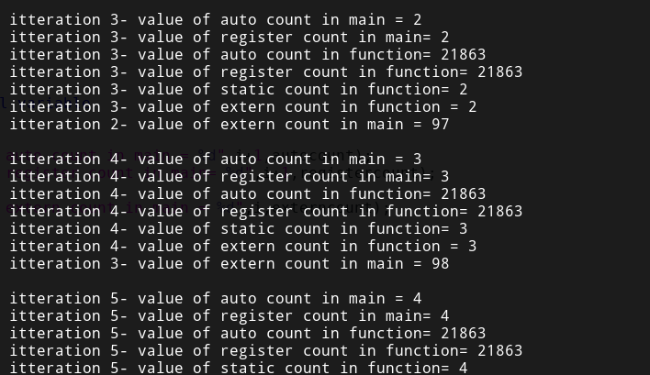

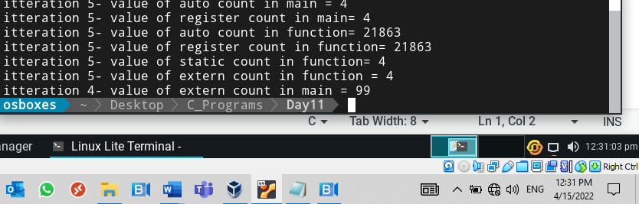

1. Write a program to demonstrate integer, float, character and string constants

Program:

#include<stdio.h>

int main()

{

const int a=100;

const char nl ='\n';

const float f1=50.654;

const char name[]="Sunny";

printf("values for const \ta =%d %c \t\t\tf1=%f %c \t\t\tName=%s",a,nl,f1,nl,name);

return 0;

}

Output:

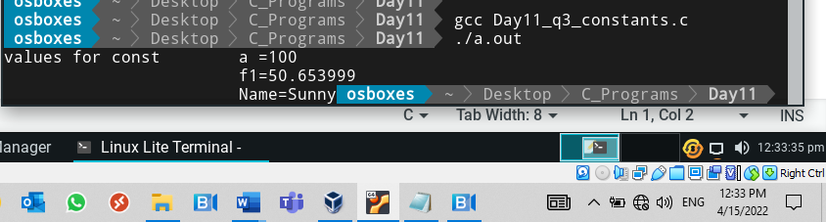

Day 12

1. **Write a program to find the volume of a sphere using macros.**

Pass the radius as the argument to the macro.

Program

#include<stdio.h>

#define PI 3.14

#define v 1.3333334

#define VOLUME(r) ((v)*PI*(r)*(r)*(r))

int main()

{

int r;

printf("Enter the radius");

scanf("%d",&r);

printf("Volume of sphare = %f",VOLUME(r));

return 0;

}

Output:

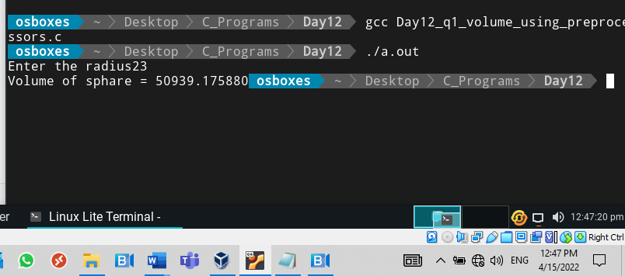

1. **Write a program to perform addition of two int or char or float numbers.**

* If we need to do the addition of two integers then it should compile the code related to the addition of integers.
* If we need to do the addition of two float then it should compile the code related to the addition of float numbers.

Use conditional compilation

Program:

#include<stdio.h>

#define CHOICE 1

#define SUM(a,b) a+b

int main()

{

#if CHOICE==0

printf("Enter the two interger numbers");

int a,b;

scanf("%d%d",&a,&b);

printf("Addtion of two integers=%d",SUM(a,b));

#elif CHOICE == 1

printf("Enter the two Float numbers");

float a,b;

scanf("%f%f",&a,&b);

printf("Addtion of two Floats =%f " ,SUM(a,b));

#endif

return 0;

}

Output:

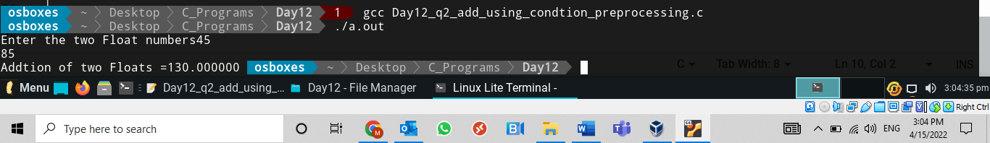

1. **Develop programs to demonstrate the functionality of preprocessor operator ## and also conditional compilation.**

Program:

#include<stdio.h>

#define ADD(a,b) a##b

#define A 50

int main()

{

int a =5, b=5,ab=10;

int c=10,bc=20;

#if(A >50)

printf("Value is %d",ADD(a,b));

#else

printf("Value is %d",ADD(b,c));

#endif

return 0;

}

Output:

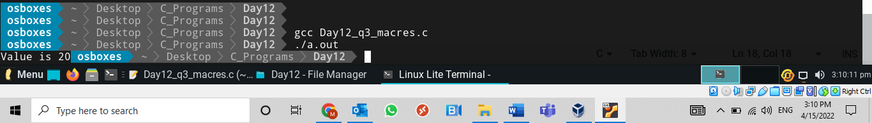

Day 13

1. **Write a program to read the Roll No, name and marks of a student and store it in a text file.**

If the file already exists, add information to it.

Program:

#include<stdio.h>

int main()

{

FILE *fptr;

int eno;

float marks;

char name[20];

fptr=fopen("studen.txt","w+");

if(fptr==NULL)

{

printf("error in opening file");

return -1;

}

printf("Enter student roll number");

scanf("%d",&eno);

printf("Enter student name");

scanf("%s",name);

printf("Enter student marks");

scanf("%f",&marks);

fputs("Roll No\t\tName\t\tMarks\n",fptr);

fprintf(fptr,"%d",eno);

fputs("\t\t",fptr);

fputs(name,fptr);

fputs("\t\t",fptr);

fprintf(fptr,"\t%f",marks);

fputs("\n",fptr);

fclose (fptr);

return 0;

}

Output:

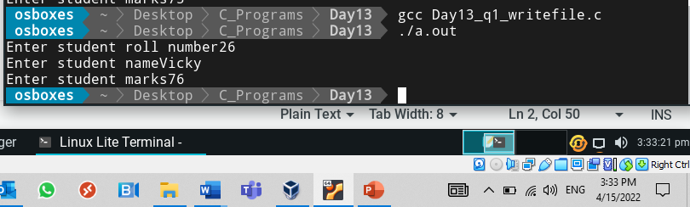

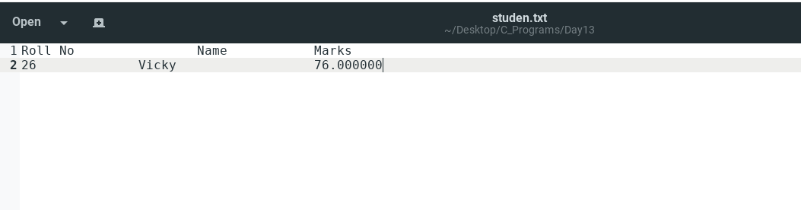

1. **Write a menu driven C program to implement “wc” (i.e NO. of lines, No. of characters and No. of words in given text file) utility of Linux.**

Take file as an input and print the following:

1. Number of characters
2. Number of lines
3. Number of words

Program:

#include <stdio.h>

#include <stdlib.h>

int main()

{

char ch;

FILE *file;

int c_ch = 0, c_word=0,c_line=0;

//Opens a file in read mode

file = fopen("studen.txt","r");

//Gets each character till end of file is reached

while((ch = fgetc(file)) != EOF)

{

c_ch++;

//Counts each word

if(ch ==' '||ch=='\t')

c_word++;

if(ch == '\n')

c_line++;

}

printf("\nNumber of chars present in given file: %d", c_ch);

printf("\nNumber of words present in given file: %d", c_word);

printf("\nNumber of Lines present in given file: %d\n", c_line);

fclose(file);

return 0;

}

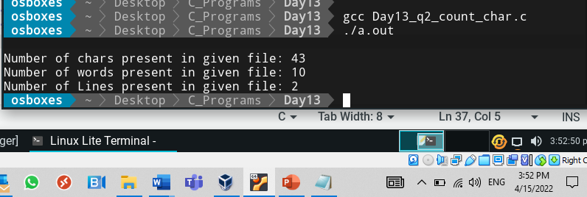

1. **Write a program that will concatenate two files, that is append the contents of one file at the end of another file and write the results into a third file**

Program:

#include <stdio.h>

#include <stdlib.h>

int main()

{

FILE *f1, *f2, *f3;

char ch;

f1 = fopen("studen.txt", "r"); //opening the file for reading.

f2 = fopen("temp.txt", "r");

if(f1 == NULL || f2 == NULL)

{

perror("Error ");

printf("Press any key to exit...\n");

exit(EXIT_FAILURE);

}

f3 = fopen("Q3_file.txt", "w"); // Opening in write mode

if(f3 == NULL)

{

perror("Error ");

printf("Press any key to exit...\n");

exit(EXIT_FAILURE);

}

while((ch = fgetc(f1)) != EOF)

fputc(ch,f3);

while((ch = fgetc(f2)) != EOF)

fputc(ch,f3);

printf("The two files were merged into Q3_file file successfully.\n");

fclose(f1);

fclose(f2);

fclose(f3);

return(0);

}

Output:

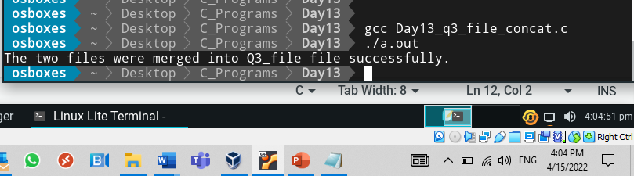

1. **Write a program to read the Roll No, name and marks of a student and store it in to a binary file and read student records and print on standard output (use fwrite and fread library functions).**

Program:

#include<stdio.h>

struct Student

{

int eno;

char name[50];

float marks;

};

int main()

{

FILE *fptr;

struct Student s;

fptr=fopen("student.txt","w+");

if(fptr==NULL)

{

printf("error in opening file");

return -1;

}

printf("Enter student roll number");

scanf("%d",&s.eno);

printf("Enter student name");

scanf("%s",s.name);

printf("Enter student marks");

scanf("%f",&s.marks);

fputs("Roll No\t\tName\t\tMarks\n",fptr);

fwrite(&s,sizeof(s),1,fptr);

fread(&s,sizeof(s),1,fptr);

printf("Roll numner = %d",s.eno);

printf("\nName = %s",s.name);

printf("\nMarks = %f\n",s.marks);

fclose (fptr);

return 0;

}

Output:

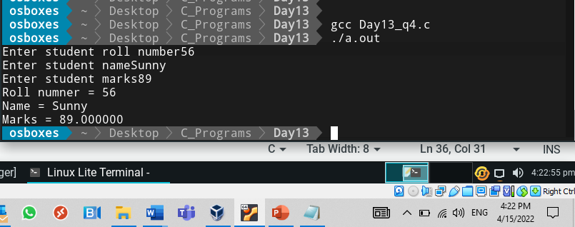

1. **Write a C program to demonstrate functionality of the fseek library function. (Use SEEK_SET, SEEK_CUR, SEEK_END. )**

Program:

#include <stdio.h>

int main()

{

FILE *fp;

fp = fopen("studen.txt", "r");

// Moving pointer to end

fseek(fp, 0, SEEK_END);

// Printing position of pointer

printf("Current position of pointer: ");

printf("%ld \n", ftell(fp));

// Moving the pointer 3 places ahead

// of the start of the file

fseek(fp,3,SEEK_SET);

int c;

printf("Bytes after the first 3 bytes:");

printf("\n");

while( (c=fgetc(fp)) != EOF)

putchar(c);

return 0;

}

Output:

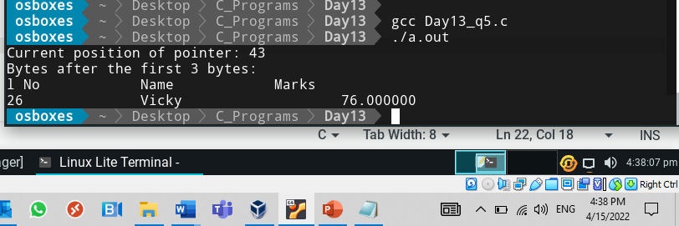

Day 14

1. **Write a program to find the smallest and greatest integers among all integers, which are provided through the command line.**

Program:

#include<stdio.h>

int main(int len, char *args[])

{

int i,n;

int great;

n=len-1;

great=atoi(*(args));

printf("Entered numbers are : ");

for(i=1;i<=n;i++)

{

if(great<atoi(*(args+i)))

great=atoi(*(args+i));

printf("%d ",atoi(*(args+i)));

}

printf("\nGreatest numbers amoung all numbers = %d\n",great);

return 0;

}

Output:

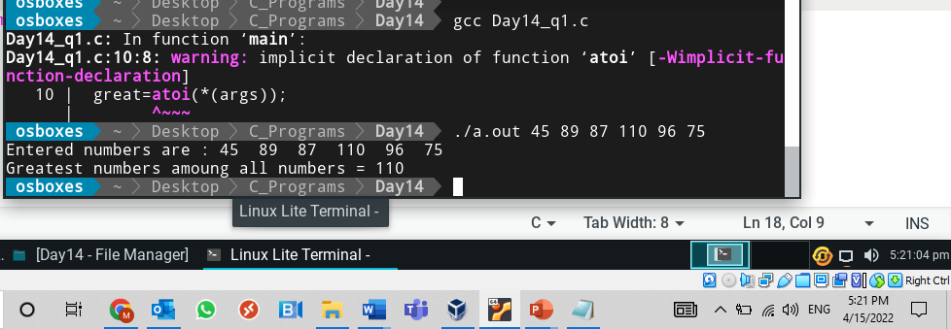

1. **Write a program to read (from standard input) the Roll No, name and marks of a student and store it in a text file (Note: Provide text file name through command line).**

If the file already exists, add information to it.

Program:

#include<stdio.h>

#include<string.h>

int main(int n,char *str[])

{

FILE *fptr;

int eno;

float marks;

char name[20];

char fname[20];

strcpy(fname,(*(str+1)));

printf("File name = %s",fname);

printf("\n");

fptr=fopen(fname,"w+");

if(fptr==NULL)

{

printf("error in opening file");

return -1;

}

printf("Enter student roll number");

scanf("%d",&eno);

printf("Enter student name");

scanf("%s",name);

printf("Enter student marks");

scanf("%f",&marks);

fputs("Roll No\t\tName\t\tMarks\n",fptr);

fprintf(fptr,"%d",eno);

fputs("\t\t",fptr);

fputs(name,fptr);

fputs("\t\t",fptr);

fprintf(fptr,"\t%f",marks);

fputs("\n",fptr);

fclose (fptr);

return 0;

}

Output:

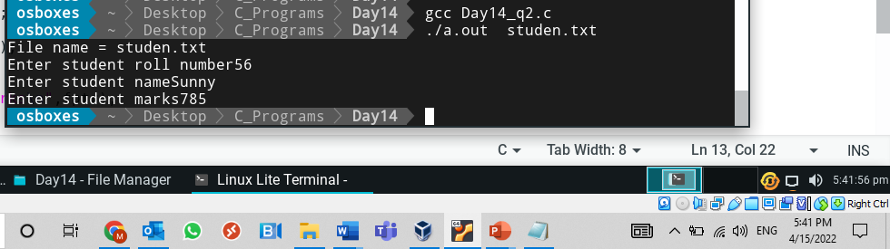

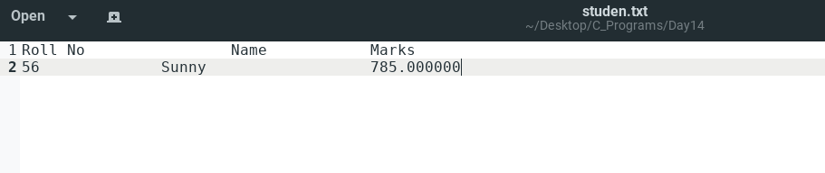

1. **Write a Make file for cleaning and building executables from multiple c source files, and header files**

Program:

Makefile:

area:Area.o Circle.o

gcc Area.o Circle.o -o area

Area.o:Area.c

gcc -c Area.c -o Area

Circle.o:Circle_area.c

gcc -c Circle_area.c -o Circle

Area.c

#include<stdio.h>

/* Function Prototype */

float area(int r);

int main()

{

int r;

float a;

printf("Enter radius:\n");

scanf("%d",&r);

a=area(r);

printf("area of Circle=%f \n",area);

return 0;

}

#include<stdio.h>

float area(int r)

{

return 3.14*r*r;

}

Output:

